Top Crops for a Depression/Survival Garden

Many factors can cause food scarcity, crop failures, economic collapse, wars, and natural disasters to name a few. Most of us have seen store shelves empty when an ice storm approaches. Now try to imagine the winter of 1944-45 when the Dutch people had to survive on tulip bulbs, at about 400 calories per person, per day. The Great Depression in America caused many Americans to rely on mostly beans, cornmeal, potatoes and various vegetables. Meat, dairy and fresh fruit were harder to come by, or too expensive because of financial hardships. Food storage in our homes provides the basics we need. A backyard or balcony garden adds flavor, variety, nutrition, and food security. Another point to consider is that fresh produce may not even be available at the stores, or if it is it may be too expensive due to shortages.

I’ve tried a lot of fun crops in my North Texas garden but have narrowed them down to the things that I would consider a survival garden. I don’t want to waste my time or garden space on plants that don’t grow well here. My criteria for this list is that between the plants I grow they must meet at least one of these requirements: High Calories, High Nutrients, Protein, Long Storage, Easy to grow in our harsh Texas conditions.

- Beans are so easy to grow. I grow bush beans for fresh eating, and pole beans for drying (which have a long storage life) Beans are high in protein, calorie dense and filling. The leaves are edible and the plant adds nitrogen to the soil, preparing it for the next crop you will grow there.
- Sweet Potatoes and their leaves. This is the EASIEST and most successful plant I grow every year. Once you start them you will never have to buy sweet potatoes again because the potatoes you save from your fall harvest will grow slips (green vines) to plant the following spring. They love the heat and practically take care of themselves. Sweet potatoes are incredibly nutritious and can be stored for about 6 months, which is very important for having food in the winter! One of my favorite things about sweet potatoes is that their leaves are edible. I can’t grow many greens during the hottest part of the summer so I harvest the sweet potato leaves and use them like spinach or kale in soups, stews and even fresh in sandwiches. I would have added Irish potatoes if I lived in a cooler climate. They don’t produce quite as well for me here, plus their leaves are toxic, so less of the plant to eat. I do grow them, just don’t get as many as I do with sweet potatoes.
- Winter Squash What I love about winter squash is how long it stores for. You can harvest it around September/October and it will last til Spring on your counter. You can also cut off a piece of it for a recipe and the cut end will heal over, allowing you to leave it on the counter for the next time you need it. It is nutritious and filling. We do have to worry about the dreaded squash vine borers here, but varieties like butternut squash and Tahitian Melon Squash are much more resilient. They also grow well in the heat.
- Greens like kale, spinach and mizuna do so well through the cooler months. The best part is you can harvest some leaves and the plant keeps growing. They are highly nutritious and can be dried for winter storage.
- Turnips Just read up on the Turnip winter of 1917 and you’ll see how these can help you survive! Both the root and the greens are edible. (the greens are very nutritious). Turnips are a cool season crop.
- Carrots are a little bit of work to germinate (see tips below for the board germination trick), but once they are started they are an easy winter crop. They are even fine under a blanket of snow. Plant in late October/early November, harvest in late March/early April. The root and leaf are edible and highly nutritious.
- Onions and Garlic are easy to grow and provide flavor, nutrition and medicinal value to your diet. Onions are typically planted in January and harvested in June. Garlic is usually planted in October and harvested late May/early June. Garlic is great because you only have to buy garlic bulbs once, then save some of your biggest cloves for planting in the fall. They both have a long storage life and the entire plant is edible.
- Herbs like rosemary, thyme, oregano, parsley, basil, and mint will give your meals variety and flavor. They also have medicinal properties that can help during stressful times.

Bonus - melons, blackberries, figs, peaches, plums, persimmons, and pears all do well in our hot climate.

Tomatoes and Peppers are always in my garden for our beloved salsa. I put up many jars of salsa each season. I probably wouldn’t spare the space in the garden during hard times though, just because it’s not really a survival food. (or maybe just one tomato plant and one pepper plant)

Gardening Tips

Don’t wait until hard times arrive! Learn to garden today so you have something in place when needed. The following tips are from what I’ve learned gardening in the North Texas climate.

What are your reasons for wanting to grow a vegetable garden? Here are some of mine:
- It made me very nervous when stores shut down during the pandemic. From natural disasters, to civil unrest, there are many reasons why that could happen again. We can store canned food but what about fresh? A vegetable garden can fill that gap.
- Nutrition. Some greens lose up to 50% of their nutrients within 48 hours of harvest. A garden allows you to harvest and eat immediately, ensuring the highest nutrients possible.
- Variety. Vegetable selection in the grocery store is limited to what stores and ships well. There are many other delicious and interesting plants that can be grown from seed.
- Although gardens are a big initial investment, over time they provide a lot of savings for your food budget. Once you’ve had a table covered in a huge tomato harvest, you’ll have a hard time paying grocery store prices for one big beefsteak tomato.
- Mental well being. Soil contains a bacteria that triggers serotonin in the brain, naturally reducing stress and anxiety. Plus, there’s something called the harvest high that just can’t be beat.
- Pollinators like bees and butterflies are declining. Planting a garden provides food for the pollinators, and in return they will make your garden flourish.

What to grow:
Think about what do you like to eat. Make a list and then start researching these 4 things:
- How much space does this plant need? Do I have enough room for this plant vertically, horizontally and is the soil depth sufficient?
- What time of year does this plant grow? Can I fit this in a spot that was previously occupied by a different season plant?
- How does this plant do with the Texas heat/cold and insects?
- Does this plant need to be started from seed or transplant? If seed, do I have enough time to get it going?
If any of the following plants were on your list, you’re in luck! These all do really well in Texas! Sweet potatoes, onions, garlic, carrots, okra, beans (especially yard long beans), peppers, tomatoes, melons, winter squash, southern peas, greens, china jade cucumber.
When you’re online shopping for seeds, read reviews carefully. You might be tempted to buy something based on the high reviews and beautiful pictures, but look to see where the reviewer lives. If it’s Michigan, that’s not a review we can trust. But if it says somewhere in the South, we can assume our growing conditions are pretty close.

To save seeds you’re going to want heirloom seeds. This is a good explanation: https://www.rareseeds.com/non-gmo
Why save seeds? https://www.youtube.com/watch?v=Njg9TSVeoDc

These are some great seed companies:
Baker Creek Heirloom Seeds https://www.rareseeds.com (my favorite, plus with every order over $10 you get a free surprise seed pack and free shipping)
MI Gardener https://migardener.com
Sow True Seeds https://sowtrueseed.com/
Seed Savers Exchange https://seedsavers.org/
Territorial Seed Company https://territorialseed.com/
Botanical Interests https://www.botanicalinterests.com/
Strictly Medicinal Seeds https://strictlymedicinalseeds.com/

You can sometimes find free seeds at libraries, or online gardening share groups. I’ve also planted flower seeds from the dollar store that germinated just fine.

Pests

It’s easy to get discouraged when plants don’t work out the way you had hoped. Every year I say I’m never planting squash again and then every year I try again. Once the squash bugs and squash vine borers find your house they will never leave. But last year I started wrapping the base of the stems in foil, and injecting BT into the stems once a week and I actually got a pretty good harvest. Here’s a video explaining those two https://www.youtube.com/watch?v=9KFULfqu4eo
If those two fail, you can always do surgery on the vine and dig out the svb worms. It’s gross but it works. https://www.hgtv.com/outdoors/gardens/planting-and-maintenance/squash-bugs-in-the-garden
And if you like butternut squash, Tahitian melon squash, acorn squash and Waltham butternut are more resistant to the svb because of their thick stems. I still had to wrap and foil and inject the stems, but they lasted a lot longer than thin stem plants like zucchini. Also, one thing I learned my first year is you can pick and eat winter squash when they’re still a greenish yellow, but if you want to store them all winter you need to let them dry on the vine until the shell is too hard to poke your thumbnail in.

Another garden pest that causes people to give up is the tomato hornworm. I’ve seen them demolish half a pepper plant in one day. They’re the same color as the plants they eat so they’re very hard to see. I found something called a blacklight flashlight on Amazon and it makes them glow neon green when it’s dark outside. Then you can easily pick them off.

Aphids are tiny but can suck the life out of your plants. They love my long beans. The best advice I can give for those is to just wash them off with a strong spray of the hose. You might have to do it every day but it works.

Cutworms are second to the svb as my most dreaded garden pest. I’ve been so happy to see bean seeds sprout a couple inches and then come out the next day to see no evidence my bean plants were ever there. The best solution I’ve found is to put little collars, or barriers around the plant (above and under the soil). A paper towel roll or toilet paper roll cut into rings will work. Another deterrent is to get the seedlings going in cups and then plant when they are a little bigger. The cutworms don’t seem to bother the bigger plants.

Grubs have moved into my garden and started munching on my sweet potatoes underground. I finally found a product called milky spores and am starting the process of getting rid of them. It’s going to take some time but I’m hopeful this will work. https://www.hgtv.com/outdoors/landscaping-and-hardscaping/how-to-control-grubs

Starting Seeds:

What kind of seeds to buy- There’s heirloom seeds, hybrids and GMO seeds.
Heirloom seeds are the ones that have been passed down from generation to generation. The advantage to these seeds is you can save seeds from each harvest, meaning you will never have to buy that variety again. You will also have a big variety of unique vegetables you don’t usually see in the stores. Plus there’s just something so cool about learning the history of each plant. Some seed histories go back thousands of years. That’s a lot of gardeners passing seeds to new gardeners!
Hybrids are a mix of two parent plants. Sometimes these have better pest resistance, survive temperature changes better, and produce more. The disadvantage is that it makes seed saving difficult because the seeds will usually produce a mystery plant. If you’re not concerned about seed saving then these can be good.
GMOs - these are usually used by large scale commercial farmers, chosen for their disease and pest resistance and increased yields. These do not produce seeds to save, and even if they did they are usually patented by the seed companies. I would not want to plant them in my garden for several reasons, the main being that increased gmo use leads to reliance on seed companies for our food. If less and less people plant and save heirloom seeds, there will be less seeds as time goes on, creating a reliance on seed companies for our seeds. If you buy heirloom seeds once, you can pass those seeds on for hundreds of years. GMO seeds must be purchased each time you want to plant them in the garden.

Now since we talked about the importance of saving seeds, this is a masterclass video on that subject. It’s not hard to do, but there’s some very important rules to follow if you want your seeds to produce exactly what you grew the first time. https://www.youtube.com/watch?v=At5xM1y27tQ

Direct sowing - plants like beans, melons, cucumbers, and squash are very fast growing so they are usually planted directly in the ground once the danger of frost has passed. Carrots do not like their roots disturbed so they do best direct sown.

Starting indoors with heat mat, fan and grow lights- Peppers and tomatoes need a head start - start those in January. Although many other plants can be direct sown outdoors, sometimes the tender seedlings get eaten by slugs or cutworms right after they emerge. Those can also benefit from getting a head start indoors.
Make sure you’re using a good potting soil, but not too nutrient rich. Fox Farms Ocean Forest is packed with nutrients, great for adding to garden, but bad for seedlings. I used it a few years ago and it was so nutrient rich it burned my seedlings and I had to start over. BM7 and Promix are good for starting seeds.
This is a good video on everything related to starting seeds indoors. https://www.youtube.com/watch?v=AjZYE_JJWQI

The biggest mistake most new gardeners make when starting seeds is thinking they can just put them in a sunny window. That rarely works. Even in the sunniest window seedlings will get leggy searching for light and you will have to throw them away. A strong full spectrum light is required, and it must be very close to the seedlings when they first emerge (like 2”). These are the lights I use. 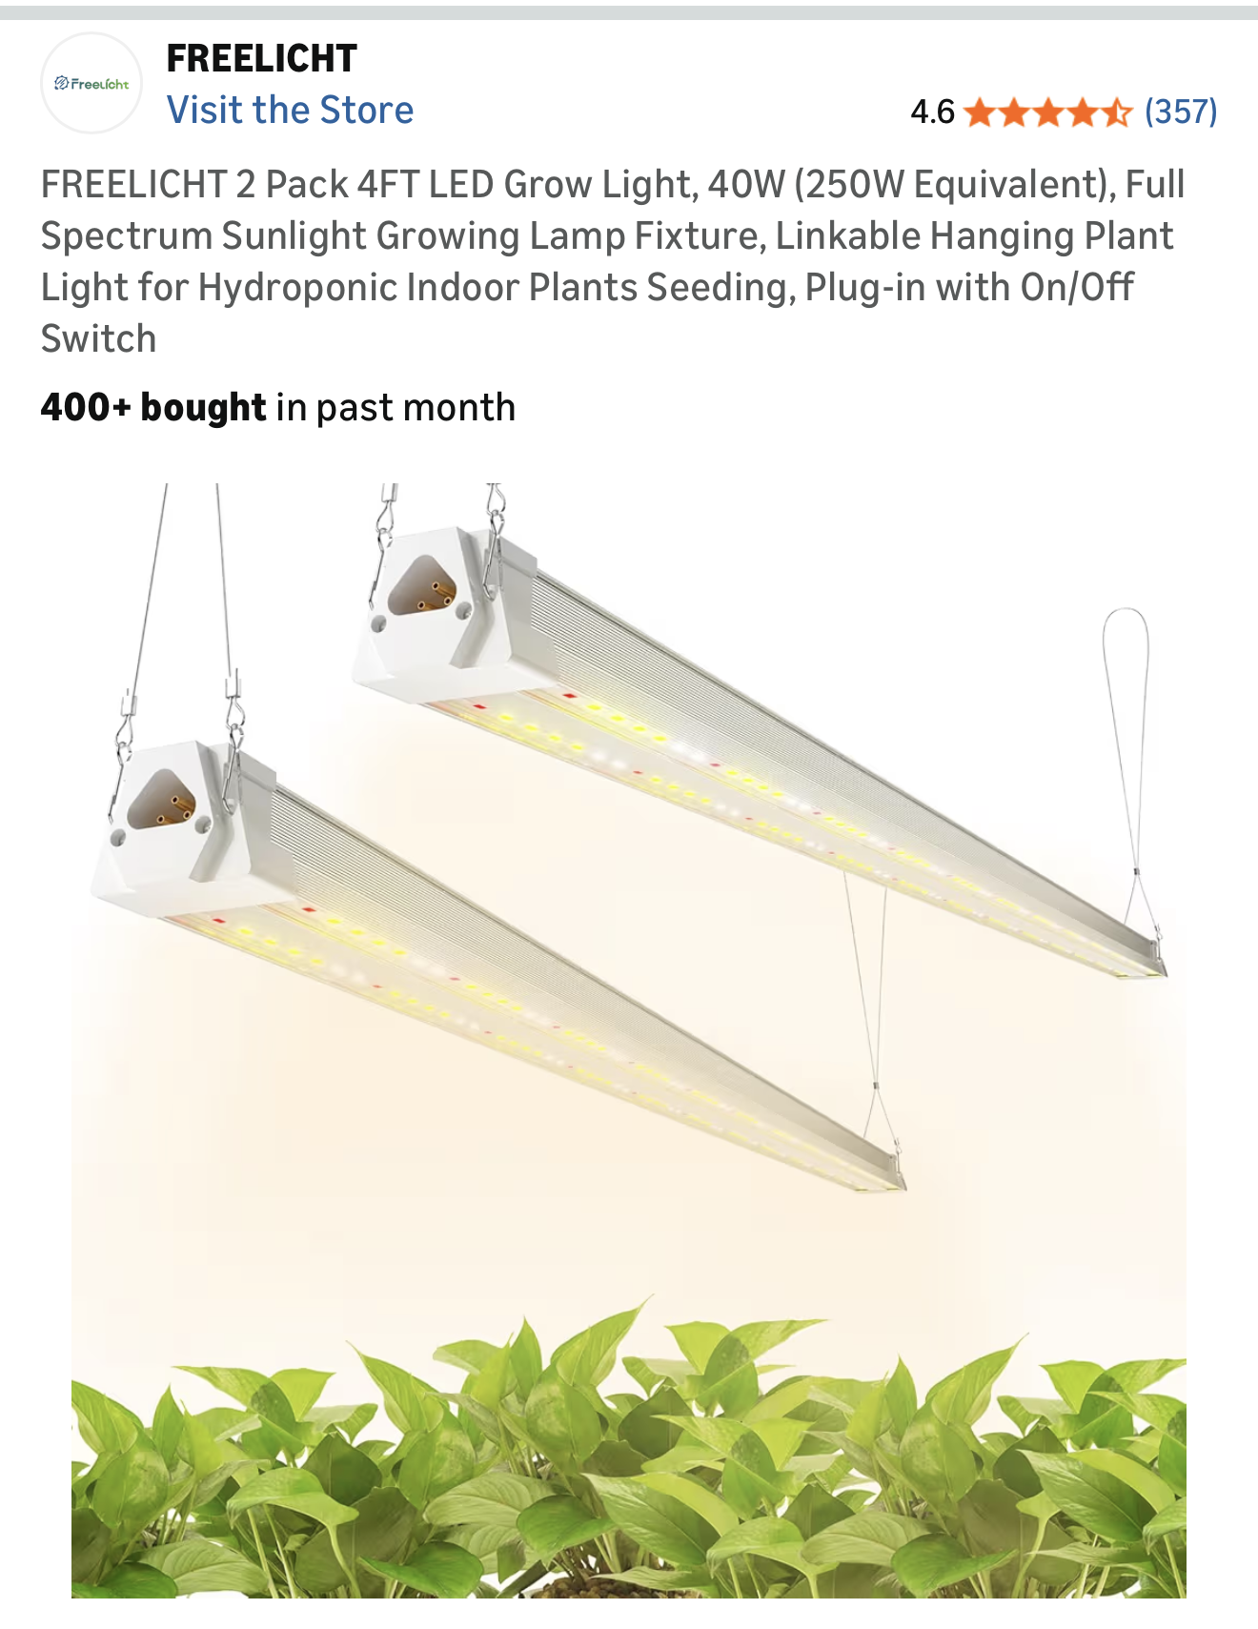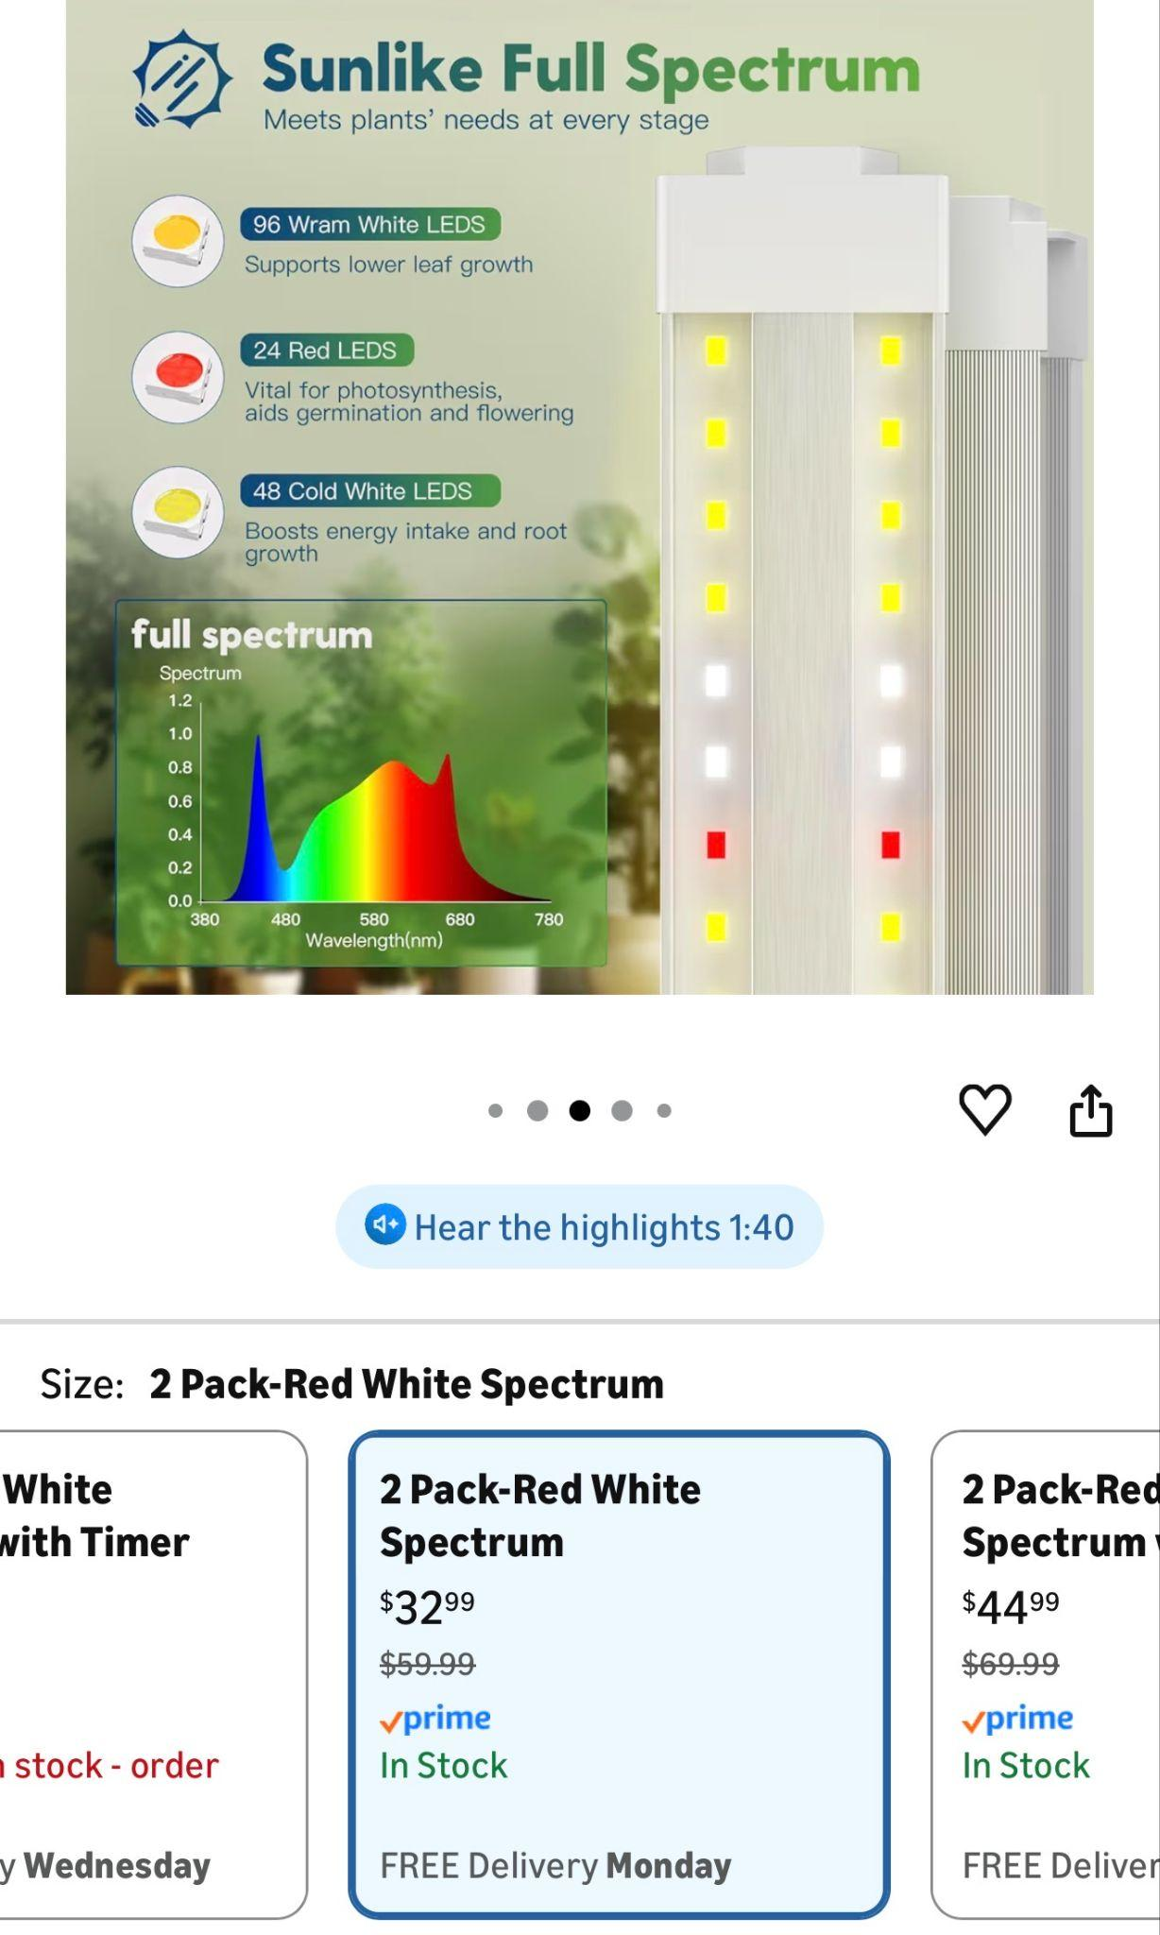

Winter sowing - Milk jugs act as little greenhouses, sheltering seedlings throughout the winter. When the weather starts to warm up you can open the jug and start the hardening off process. Winter sown plants are usually very healthy and strong. The biggest reason I winter sow is to give my plants a healthy head start. But another reason is the bugs usually leave the bigger plants grown in the jug alone, vs the tender seedlings that I planted directly in the ground. Cutworms particularly were eating my bean seedlings within a day of them emerging from the ground. xmg.org/rockwall/winter-sowing-method/

Snail Rolls - This is new to me because I just discovered it yesterday. I just spent the last hour making several of them and I’m excited to see how they do. The advantage to this is saving space, while also allowing the roots room to spread. I did mine in parchment paper just because that’s what I had on hand, but in a different video I saw it mentioned that bubble wrap might keep the seedlings from drying out better. https://www.youtube.com/watch?v=xrrhvp8-QVg

Other plants:
I paid for my first seed garlic (not cheap) but haven’t had to buy it since. You can also take a chance with organic garlic from the store to see if it sprouts.
Plant in October and harvest in June. Save your biggest garlic bulbs from your June harvest and plant the largest cloves in October. This will allow you to buy ONCE and harvest forever In North Texas we need the softneck variety, they can get huge. I actually grow both softneck and hardneck. I like how big softneck gets, but I hate how there’s so many tiny cloves in the bulb. Hardneck is smaller but has just a few big cloves, plus it creates a delicious scape. Garlic is the #1 medicinal plant in my garden. https://thedallasgarden.com/when-and-how-to-plant-garlic-in-north-texas/

Onions can be started from seeds, but they’re cheap to buy as sets in January so that’s what I usually do. You can buy them online but most feed stores and nurseries carry them. I got big onion sets at Home Grown Plants in Farmersville yesterday for $2.95 a set and they were from Dixondale Farms (the best).

In North Texas we can do short day or intermediate day onions. Plant in January and harvest around June. Onions are another medicinal plant and so good for you! This website is fun to look at all the different varieties. They are a Texas company so their planting advice is great for our area. https://dixondalefarms.com/onion-planting-guide

Sweet potatoes! The number one survival food in my garden! The whole plant is edible. Incredibly nutritious and full of fiber. It stores all winter long and while it’s in storage it’s growing next year’s plant! Just pop these off and put in water and by May you’ll have slips to plant. I recently discovered a new way to grow sweet potatoes that is economic and easy. Get a few cheap laundry baskets from the Dollar Tree and line them with tulle or old cut up sheets from a thrift store. Instead of expensive soil to fill them, use half soil, half straw, layered lasagna style. On the top layer put a little soil and plant your sweet potato slips in there. The 10 baskets I did this year produced even more than the ones grown in expensive pots. I’ll always do them the laundry basket way in the future. Great video on starting sweet potatoes. https://www.youtube.com/watch?v=0igp5IzO21g

Carrots gave me a lot of trouble in the beginning because I didn’t know about the board sprouting trick. Laying a board down right after sowing seeds keeps them moist and prevents them from washing away in a big rain storm. This video shows exactly how to do that. https://www.youtube.com/watch?v=gpXvQVSS1Hg I sow seeds around early November and harvest around April. I will only cover with a blanket if it’s going to be a hard freeze (like 20 degrees or below).

Irish Potatoes These can be grown in the spring and fall. I have grown from both nursery seed potatoes and potatoes from my pantry that have sprouted. Right now (January) I have some nursery potatoes in a sunny window. The next few weeks I’ll be letting the sprouts grow from the “eyes”. Then I will cut them in golfball size pieces, with one or two eyes per chunk. I will then let them sit, cut side up, to dry for a day or two. Then I will coat the pieces in powdered sulfur (to repel pests), then plant in the garden (ground, raised beds or containers).
They can handle cold weather. In fact you will want to give them an early start so that they can produce as many potatoes as possible before the heat arrives (when they will stop producing). You’ll know they are ready when the top green leaves die back. This is a good video on planting potatoes. This video explains planting irish potatoes. https://www.youtube.com/watch?v=ianApRDflh0

Plant perennial medicinal herbs throughout your garden for pollinators. Thyme, mullein, sage, rosemary, oregano, yarrow, lemonbalm, echinacea, peppermint, etc. (some of these spread and are better in pots)
In the spring calendula and marigolds will help draw the bugs away from your plants. Calendula is more like a trap crop, meaning the bugs will eat it instead of the vegetable plant right next to it. Calendula doesn’t do well in the heat so after June the marigolds will be growing large and taking over. This past year I had the biggest orange cosmos plant I’ve ever seen. It brought in so many pollinators that I’m going to be adding that one every year. Zinnias are great as well.

A friend of mine does something called chaos gardening. It’s a little too crazy for me but I did pick up some of her ideas and now try to fill all available space with something. Okra is great because it doesn’t take up much space in the garden. Or even just flowers here and there. My harvests have increased since I started that. My garden for the most part is pretty organized with where I plant things, I just try to fill all the spaces if possible. That helps keep moisture in as well. And adding things like basil, onions, lemongrass, garlic and marigolds can help repel pests.
But if you have some extra space and seeds, like to live on the edge, and want to just see what grows, this might be for you. https://youtu.be/dLZzzbqHt7Y?si=kLVLY8fE4PbMi6ZF

Picking the right vegetable for the right season: One of the first mistakes I made in gardening was planting seeds or transplants without paying attention to their growing season. For several years I’d try to grow cilantro over the summer and it would almost always go to seed by June. It’s the middle of January right now and my cilantro is happy as can be in this cold weather (near freezing at night). This is a helpful planting guide for our area of Texas. https://www.ufseeds.com/vegetable-planting-calendar-dallas-texas.html?srsltid=AfmBOoohPKQ6RmcUsO3-fIXjxyJTsvzUnT05BB68LnHLOb2VNdNQCw7A

Fertilizer:
Plants are hungry and will deplete the soil of nutrients. It’s necessary to feed your garden throughout the growing season.
Some methods to consider:
Burying kitchen scraps in the soil to decompose over time (I do this all winter long).
Compost (I’ve made some beautiful black compost in a big plastic tote with holes drilled in the top, bottom and sides, set on bricks to elevate it above the ground) Here’s an instructional video https://www.youtube.com/watch?v=m6B4la6SMzM

Manure (well composted or aged or it will burn your plants), although alpaca and rabbit manure can go directly on the garden. Check the local school ag barn near you to see if they will let you pick up from their manure pile. You’ll need to let it sit for 6-9 months before using it, but you can speed this up in the summer by covering with a black bag and letting it “cook” in the heat for 3-4 months.
Alaska Fish Fertilizer (or fish) - plants love this stinky stuff so much.
Comfrey - this plant is not only healing to humans but it feeds the plants around it as well. You can chop and drop the leaves in the garden like mulch, or bury some leaves in the ground around plants. A compost tea can also be made by chopping some leaves and letting them sit in a bucket of water for a few weeks. It will need to be diluted 1:10 before watering the garden. (I prefer the chop and drop method because the tea smells so bad.)
Beans add nitrogen back into the soil so consider putting some beans in empty spots throughout the garden.

Planning your garden space: planting in the ground, containers, raised beds , I’ve tried every one of these!
Containers- There are many reasons why containers might be a good option, low on space, keep bunnies out, less ground dwelling insects, can keep things like lettuce cleaner, can be done in an apartment setting.
This guy has acres of land but chooses to do only container gardening. See why in this video: https://www.youtube.com/watch?v=CJZ-qGIuiWk

Raised beds - usually wood or metal. This is a video on an inexpensive way to do wood beds using Home Depot corner blocks. https://www.youtube.com/watch?v=5YAUDuNLnpQ
*Just as a side note though, the grass in that video is not bermuda grass. If you are putting raised beds down on bermuda grass it’s a good idea to put down cardboard over the grass to help suppress it (or dig it out). Bermuda is the WORST weed to try to control in the garden.

My first raised beds were wood. They were mostly free because I used the scrap wood in the new construction trash piles in my neighborhood. They were beautiful and lasted 5 years, but then fell apart from rot. Last year I invested in Vego garden beds. They claim to last 20 years. I am very impressed with their quality and would love to add more in the future. https://www.vegogarden.com/

Probably the biggest expense in all of this is going to be your soil! Some people have land with great soil, but most of us in the suburbs are going to have to bring in our own.
Filling containers takes more soil than you think. For raised beds, even if you fill the bottom of your beds with mulch, tree branches or sticks, you’ll still need a lot of soil. If you have more than one raised bed you may be better off buying soil in bulk vs bagged. It will save you a lot of money. There are places that will let you drive your truck in and they’ll fill it with soil. Or you can have them delivered for a fee. I had 6 yards of a topsoil/compost blend delivered for my first garden beds and it was just about the perfect amount. The truck dumped it in my driveway and I hauled it to the backyard little by little. A lot of work but so much cheaper than buying bagged soil. The place I bought from is gone but here are two local places that have good reviews. https://www.texaspureproducts.com/
And https://www.livingearthtechnology.com/
Make sure to find a sunny spot for your garden, at least 6-8 hours of sunlight. Avoid low areas due to flooding and frost. Adding some kind of trellis will help for things like tomatoes, melons, beans, cucumbers, etc. Tomato cages are great for peppers and determinate tomatoes, but indeterminate tomatoes will need something taller to grow up.
I recently found a great winter use for tomato cages. I put a bunch of them close together and then planted my winter veggies in the middle. I then covered the cages with netting, weighed down on the sides with bricks. This is the first year bugs have completely left my winter vegetables alone.

Succession Planting: How do you keep plants growing every month of the year? Simple, cycle warm/cold weather plants so there’s never a gap. This takes a bit of planning but once you figure out the sowing/harvesting times of each plant, you can figure out which plants can follow each other in the same space. For example:
Onions are planted in January and harvested in June. Next I’ll plant winter squash in that spot and harvest in October. Then I’ll plant winter crops like cauliflower, kale, broccoli, turnips, beets, etc and those will stay in the ground until Mid January when I plant onions again.
Another example is carrots from November - April, then sweet potatoes from May to October.
Or Carrots November - April, then peppers April to November.

Since most beds are getting switched out for something in the fall, this is a good time to practice crop rotation. So the cycle I had going in one bed, I’ll switch with another bed. This will help cut down on nutrient depletion and pest problems. I didn’t do this for 3 years in a row and developed a bad grub problem in the bed where the sweet potatoes were. I bought something called Milky Spores which is supposed to get rid of them over time.

Things that help you get a much bigger harvest:
This video has GREAT tips! https://www.youtube.com/watch?v=e4G5qiy4djc

The tip she gives on tomatoes is probably my favorite. I’ve learned that in Texas we really only get 2 good seasons for harvesting tomatoes, Spring and Fall. You can harvest smaller types like cherry tomatoes throughout the heat of the summer, but the big tomatoes will sometimes take a break during the hottest part of the summer. It is possible to water like crazy all summer and keep your spring tomato plants alive, but sometimes they get stressed and don’t produce as well in the Fall.
What I like to do is find my best producing tomato plants and clone them. Basically that’s taking a sucker (the tender growth between the thick stem and leaf), cut it off and root it in water. Once it has good roots, plant it in a pot and water that, instead of the big sprawling plant it came from. I’ll get a bunch of suckers going and rip out all the old plants they came from. When you see the worst of summer is almost over, plant those in the ground and watch them take off. They produce so much more fruit for me than the ones left in the ground from Spring. The video link above shows how to do that.

Other random tips:
-Have a plan for what you are going to do with all of your harvest and how you will preserve it. Salsa is great, but you really don’t get all of the ingredients ready at the same time. I like to keep my June garlic in the fridge, freeze the onions and tomatoes, and then in the fall when all the peppers come in I can make salsa.
-China Jade cucumber is the only cucumber I’ve found that can go all summer long and stay crisp and sweet. Baker Creek sells these.
-When growing carrots or onions, if they send up a big seed stalk, pull them! Onions with a seed stalk will need to be eaten quickly and carrots with a stalk will probably be trash because the center core will be too hard to cut through.
-After harvesting onions and garlic they need to be laid in a shaded area until the stems are fully dry before they can be put in storage.
-Tomato hornworms are so hard to see because they blend in with all the green around them. But if you get a blacklight flashlight and go out at night, they will glow and you can just pick them right off.
-Get a garden calendar and schedule time to water, weed and fertilize your garden. If you don’t plan it out you’re likely to forget. Mark it off when you’re done so you can keep track.
-Keep a journal of mistakes and how you fixed them because you will forget
*****I hope these tips help! -Becky Potz pbrookp@gmail.com

