Dutch Oven Cooking 101 – The Basics
by Bret Terry – tx.terrytribe@gmail.com

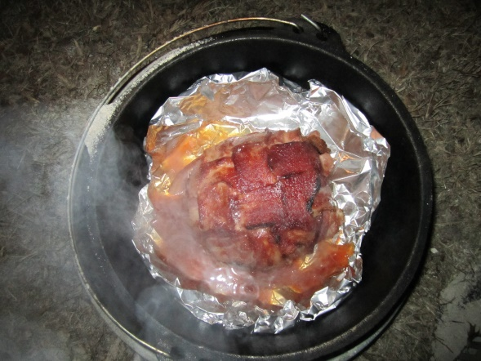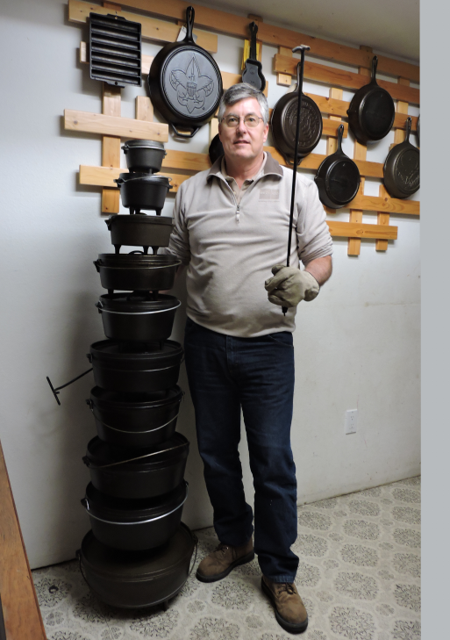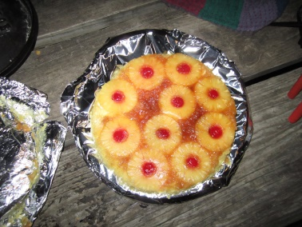

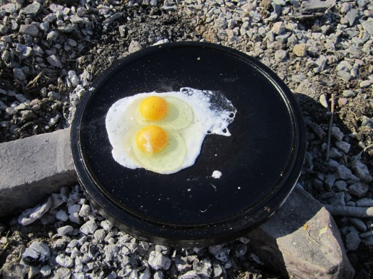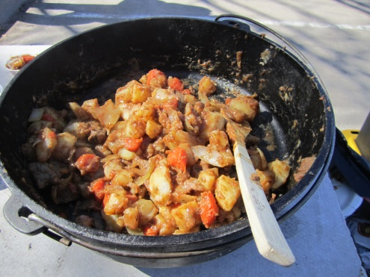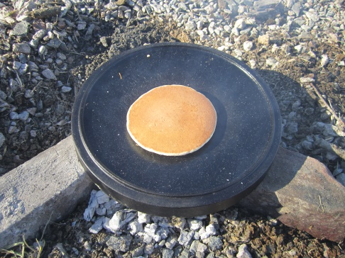

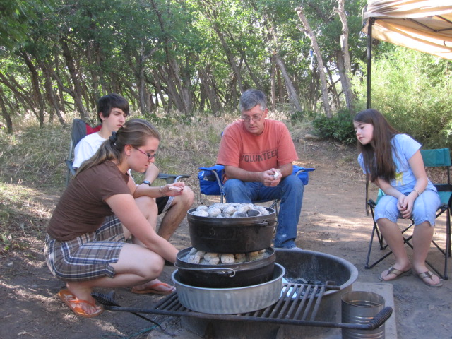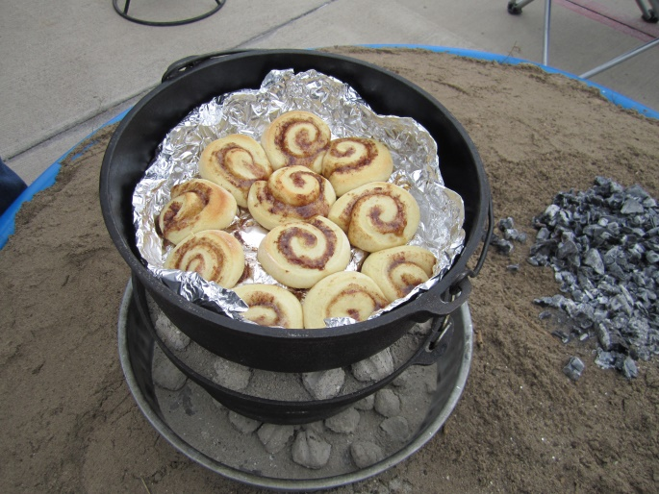

DUTCH OVEN COOKING 101 – THE BASICS
by Bret Terry – tx.terrytribe@gmail.com

Dutch Oven vs. Camp Oven – Know the Difference!
There are two types of dutch ovens (DOs). The traditional indoor style DO and the outdoor style camp oven.

The traditional indoor DO functions as a baking pot or roaster and is designed to be used within a larger gas, electric or wood burning oven. The traditional indoor style DO has a flat bottom with no legs and typically has a domed lid without a raised lip at the outer edge. Most DOs of these types also have raised bumps or ridges on the inside of the lid that drip moisture back onto the food being cooked, thus they act as roasters. These are fantastic for indoor cooking because there are no feet to get caught in the oven rack; however, they are a poor choice for outdoor use.

The outdoor style camp oven (CO) is the ideal type of DO for outdoor and emergency cooking. It is designed for use over hot coals. A CO has legs on the bottom which hold it up above the coals allowing oxygen to reach the burning coals so that they will continue to burn. No oxygen = no fire = no cooking. A CO is also designed to hold hot coals on the lid. COs have lids with a raised lip around the outside edge which keeps the coals on the lid from falling into your dish. Try cooking with coals on top of a traditional indoor style DO while removing the lid to check on your dish. If you do, I can guarantee that you will be eating ashes along with whatever you intentionally placed in your DO.

There is a Reason It’s Called an Oven – It is an OVEN!

The oven in your kitchen is basically a square metal box with lower and upper heating elements inside the box. It has internal racks that let you control where you place the food in relation to the position of the heating elements. Knobs or buttons on the outside of the oven allow you to control how hot it gets inside the metal box. A CO style DO is basically the same thing. It’s a round metal box, with lower and upper heating elements (hot burning coals) on the outside of the box. Trivets, bake packers, or a simple foil coil performs the function of an oven rack. You control how hot it gets inside the box by controlling how many hot burning coals you place under and on top of the CO. If you are not afraid to cook with the oven in your kitchen, you needn’t be afraid to cook with a CO.

Anything You Can Cook in an Oven at Home Can be Cooked in a Dutch Oven – But it Will Taste Better Coming Out of a Dutch Oven!

There is nothing you can cook in your oven at home that you cannot cook in a CO. I have baked birthday cakes, bread, pizza, cinnamon rolls, chocolate chip cookies, fruit cobblers and pineapple upside-down cakes. You may need to vent your lid for some dishes to allow some of the moisture to escape. I have cooked stews, soups, dumplings, baked beans, potatoes with bacon and onions, BBQ chicken, fajitas, roasts, casseroles, and my all-time favorite “bacon blanketed meatloaf”. I’ve even turned the lid of my CO upside down and used it as a griddle to cook pancakes, eggs, bacon and tortillas. Try getting a griddle out of your kitchen oven just by turning it upside down! The magic of dutch oven cooking is that it just tastes better. You don’t have to take my word for it, you can prove it for yourself.

What Size of Dutch Oven Do I Need? – Understand What That Number on the Lid Means!

That number on the lid of the CO is referred to as the size of the CO. A CO with a “12” on the lid, the most common size of CO, is said to be a “size 12” or a “number 12” CO. The number on the lid represents the diameter of the lid in inches. The number does NOT equate to the volumetric capacity of the CO; however, you will often see Craigslist, eBay or other advertisements mistakenly overstating the quart capacity of a CO as equal to the number on the lid. The standard depth of the smaller COs is about 3 inches while the standard depth of the larger COs is about 4 inches. Some camp ovens are manufactured with a “deep” option that typically provides one additional inch in depth over the standard depth version of the same size. The deep ovens are handy when cooking breads, roasts, and other meals that sit higher than a stew or casserole would.

The volumetric capacities of COs are a function of both the diameter and the depth of the ovens. The capacity of one brand, Lodge, is as follows:

#5 – 1 Pint #12 – 6 Quarts
#6 – 1 Quart #12 Deep – 8 Quarts
#8 – 2 Quarts #14 – 8 Quarts
#10 – 4 Quarts #14 Deep – 10 Quarts
#10 Deep – 5 Quarts 316 – 12 Quarts

While the proper size of the CO depends on what you are cooking, as a good rule of thumb, a #10 standard CO is sufficient for meals for 4-6 people; a number 12 standard CO is sufficient for meals for 6-10 people; and a #14 standard dutch oven is necessary when cooking for large groups of people. Depending on the number of people you are cooking for, you may need more than one dutch oven.

Where’s the Best Place to Buy a Camp Oven Style Dutch Oven? – The Internet of Course!

You can buy a brand NEW CO anywhere sporting goods are sold. Camp Ovens are sold at Wal*Mart, Academy Sports, Cabela’s, Dick’s Sporting Goods, Bass Pro Shops, Gander Mountain, etc. These stores typically do not carry more than one or two brands and they don’t carry the entire line of all available sizes. If you want to buy a CO for less money, and have a greater selection to choose from, then you need to go online. You can go to Wal*Mart’s online site to buy a CO at very competitive prices and have it shipped to your nearest Wal*Mart store where you can pick it up without any shipping costs. Wal*Mart offers more size selection online than what they carry in their stores. The greatest selection and lowest prices I have ever found for new COs is at Amazon.com. Cast iron is heavy and the shipping costs can often be more expensive that the CO itself, but both Amazon.com and Wal*Mart usually have some choices with free shipping.

If you want to buy a USED CO, the best prices are found at garage sales, although it may take you a while to come across one. Craigslist and eBay are online sources you can use to find a good used CO. Craigslist prices are usually lower than eBay, but you typically have to travel to the purchaser’s location and pick it up yourself. The shipping cost associated with eBay purchases typically drive the total cost higher than what you could pay for a new CO at Wal*Mart or Amazon.com. Keep in mind that if the previous owner did not properly maintain the CO, it may need to be cleaned of sticky carbon build-up and/or rust and then re-seasoned before you cook with it. You can clean and re-season a used CO yourself or have someone who collects and restores vintage cast iron do it for you.
What Dutch Oven Should I Buy? – When it Comes to Cast Iron Cookware, It Pays to BUY AMERICAN!

I own an imported car, and I own electronics imported from all over the world. It’s pretty hard, in fact, to buy almost anything made in the U.S. these days. But when it comes to cast iron cookware, the best quality, and the easiest to maintain, is in fact cast iron made in the USA. Imported cast iron cookware has a rougher, more porous finish both on the inside and outside. Imported cast iron is more difficult to season and maintain. The porous nature of imported cast iron holds more moisture and allows rust to form faster. And due to the more porous finish, when it does rust, it rusts deeper, making it even harder to clean. The wall thickness of imported cast iron COs is often thinner and therefore more susceptible to cracking, chipping and breaking. The lids don’t fit as tight and allow too much steam to escape while cooking. For most dutch oven dishes, it’s the steam that does the cooking. Imported cast iron COs are usually less expensive to purchase than COs made in USA, but the quality is lower as well. In the end, you get what you pay for.

American made cast iron cookware is still the best quality cast iron on the market. Lodge is the only American foundry that still produces cast iron cookware in the United States. Lodge’s COs and other non-enameled cast iron cookware comes pre-seasoned from the factory (as does some imported cast iron as well). If you want to buy brand new American made cast iron, Lodge is your only choice, and it is a good choice. All other new cast iron cookware sold in the United States today is imported, regardless of the brand name it is sold under (i.e. Camp Chef, Wenzel, Bayou Classic, Old Mountain, Texsport, Coleman, Bass Pro Shops, etc.).

There are many brands of good quality used and vintage cast iron that were produced by American foundries that are no longer in business. COs that were produced by these companies over 100 years ago are still sold and traded today via Craigslist, eBay, flea markets, antique stores, garage sales, etc. Good cast iron will last forever, so many of these COs are just as good today as they were the day they were originally made. Most cast iron produced prior to 1960 have very smooth milled cooking surfaces. Much of this older vintage cast iron is highly sought after by collectors and comes with hefty price tags. Griswold and Wagner Ware are two brand names of the more expensive collectible COs. But foundries that produced brands such as Birmingham Stove and Range Works (BSR), Martin Stove & Range Company (Martin), Vollrath, Wapak and Favorite also produced good quality COs that sell for much less than the Griswold and Wagner Ware brands do.

How Should I Clean A Camp Oven After Cooking In It? - Hot Water Only, No Soap & Dry It Completely!

The best way to clean any cast iron cookware, is to clean it while it is still hot. Therefore, remove the cooked food from the CO shortly after it is done cooking. This means that you may not be able to serve out of the CO unless its entire contents are emptied quickly. And it means that you may have to clean it before you sit down to eat. Do not let the CO sit with food in it to dry out and stick to the cast iron. While the CO is still hot, but cool enough that you can safely hold it, wash it out with hot water, but do not use any soap. Soap will remove the seasoning. Do not use cold water on hot cast iron as it could crack the cast iron. You may use a soft bristle (nylon) brush to wash it out with, but do not use anything that is abrasive such as steel wool or a metal scraper that will cut into the thin layer of seasoning. After all the food is washed out, dry it inside and out as best as you can with paper towel. (You may use a dry cloth, but the cloth may not come completely clean after using it on cast iron.) Then put the CO back on the hot coals with the lid slightly askew and heat it up to completely drive of any remaining moisture. The lid needs to be askew so moisture won’t get trapped inside the CO.

Do not clean your CO by “burning it out” over a fire and then wiping out the ash. The excessive high heat will burn off all the seasoning and you will have to re-season it to keep it from rusting. And the excessive high heat changes the nature of the metal which makes it even more difficult for the new seasoning to bond to it.
How Do I Season/Re-season My Cast Iron Camp Oven? – Seasoning, Like Onions, Has Many Layers!

The best seasoning consists of not just one, but multiple thin layers of baked on vegetable oil. Some prefer olive oil, others prefer flax seed oil, some use standard vegetable oil, and others use shortening or lard. Truth be told, you can use almost any kind of vegetable oil to season cast iron. I prefer to use Crisco shortening. Seasoning cast iron over a fire can be done, but it’s much easier to do it at home in the oven and have it ready to use before you need to use it. Keep in mind that this process produces smoke which may set off a smoke detector, so you need to open a window or turn on the exhaust fan above your oven appliance. If you have an outdoor BBQ grill with a closing cover, you can use it instead of your kitchen oven. The steps below are the steps I use to season all my cast iron in an oven at home:
- Thoroughly clean the CO with hot water as described above.
- Place the CO and the lid in the kitchen oven, but do not have the lid on the CO itself.
- Turn on the kitchen oven to at least 250ºF.
- Leave the CO in the kitchen oven for about 20 minutes. This dries the CO and opens the pores in the metal.
- Using insulated gloves or oven mitts, remove the cast iron from the kitchen oven.
- While the cast iron CO is still hot, but not so hot that you can’t hold it with cotton rags (cut up old T-shirt), pour a tablespoon or two of vegetable oil or shortening into the CO bottom and onto the CO lid.
- Use a cotton rag to cover the entire CO bottom and lid, inside and out, with the oil or melted shortening. Use enough oil so that the pores of the cast iron can’t hold any more oil.
- Use another rag to wipe off the excess oil. You are not trying to remove all the oil, but you need to remove enough of the oil that it cannot drip or run down. You want a thin coating of oil remaining on the cast iron. If a little oil is good, more is NOT better. A thick layer of oil will result in a sticky, gooey, running mess instead of a hard seasoned shell on your CO. Remember, the best seasoning is accomplished with multiple thin layers and not a single thick layer.
- Place the CO bottom piece upside down on an oven rack in the kitchen oven.
- Place the CO lid right-side-up on an oven rack, or on top of the feet of the CO bottom piece, in the kitchen oven.
- Allow the CO to sit in the oven for about 10 minutes at 200ºF.
- At five to ten minute increments, turn up the heat in the oven by 50-75ºF increments until the oven is at least 375ºF but not over 425ºF. You have to get the oven hot enough to get the oil to “smoke” in order to get the chemical reaction of polymerizing the oil. Different oils smoke at different temperatures (i.e. Crisco shortening requires a higher temperature to reach the smoke point than standard vegetable oil does.) If it doesn’t smoke for a little while after reaching 375ºF, it’s not hot enough. If it’s smoking, it is hot enough.
- Bake the cast iron for an hour.
- After an hour, turn off the kitchen oven, but do not remove the cast iron. Let the oven cool by itself and then remove the cast iron after it has completely cooled. (You don’t want to season your cast iron right before you need to use your kitchen oven. I like to season my cast iron just before going to bed at night, so I can turn off the oven and let it cool overnight.)
- Your CO is now ready to be used.

What Type of Utensils Do I Use With My Camp Oven? – Don’t Scratch Off the Seasoning!

Do not use hard metal spoons, spatulas or scrapers on seasoned cast iron as it will scratch off the seasoning you have worked so hard to build up on your CO. Use wooden spoons, wooden spatulas, or heat resistant Teflon or silicone utensils.
What Else Will I Need to Go Along With My Camp Oven? – The Must Haves and the Ooh-La-La Toys!

The necessities include:
- A Lid Lifter – Lifts hot lid off of camp oven so you can stir or check on the dish being cooked.
- Insulated Gloves or Oven Mitts – Fire is hot; enough said.
- Tongs to move charcoal briquettes, or a shovel to move hot wood coals.
- A nylon brush – Clean the oven, but don’t remove the seasoning.
- A Meat Thermometer – Insures the core temperature of meat reaches the appropriate safe temperature.

The optional toys include:
- A charcoal chimney starter – Faster way to get your briquettes burning.
- A camp dutch oven lid stand – A place to set that hot lid down without getting the inside dirty.
- A nylon carrying case – Easy way to tote that heavy oven.
- Parchment paper dutch oven liners – Makes cleaning much easier and protects your seasoning.
- Outdoor cooking stand – Don’t bend over; raise your dutch oven cooking to table height.

What Am I Going to Cook? – Limitless possibilities!

Dutch oven cooking isn’t rocket science, it’s just a great way to cook outdoors. Cook anything you like to eat that can be cooked in your kitchen oven at home. Use your favorite recipes from your own recipe box, or be adventurous and try out some of the thousands of dutch oven recipes posted on the internet. Most of the dutch ovens you can buy will come with a free recipe book inside. And remember, dutch ovens are for main dishes, side dishes, breads, desserts, and much more. You can also use your favorite search engine to search for outdoor dutch oven recipes and cooking ideas:

