Preparedness Ideas for On the Road

Canned Oxygen
Small, canned oxygen can help you in the following ways:
-High Altitudes if you have trouble breathing in high altitudes this will help give you an oxygen boost.
-In a Disaster when air quality is not optimum.
-Trapped in a tornado shelter, or room in your home after a natural disaster when air quality is not ideal.
-Breathing issues such as asthma or other health breathing issues.
-Use before, during, and after strenuous physical activities.

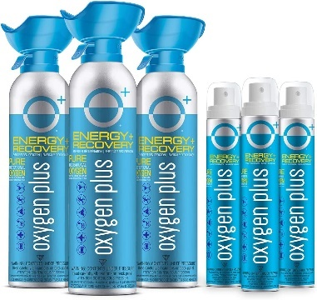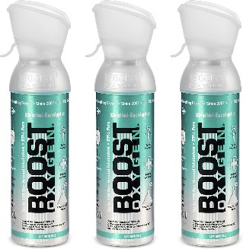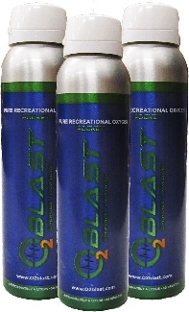
**Highly Flammable, keep away from Open Flames**

Inflatable Solar Lights
These are compact when not in use and you inflate them for more light. They can be utilized in areas when electricity is not available, such as camping, and can be used in your home when the power goes out instead of candles that could be knocked over.
They come in different sizes and colors and some with a USB adapter.

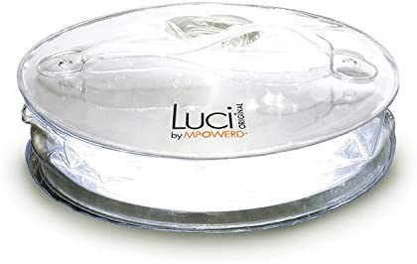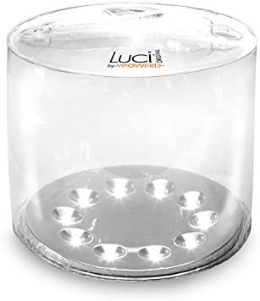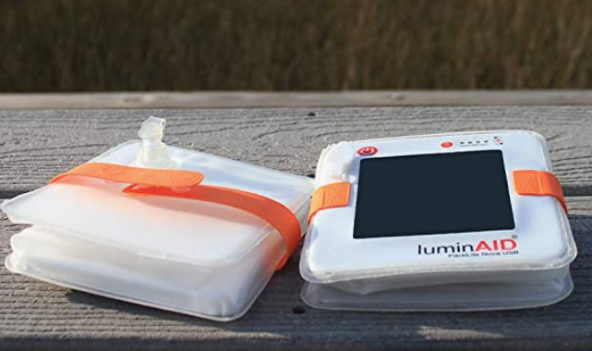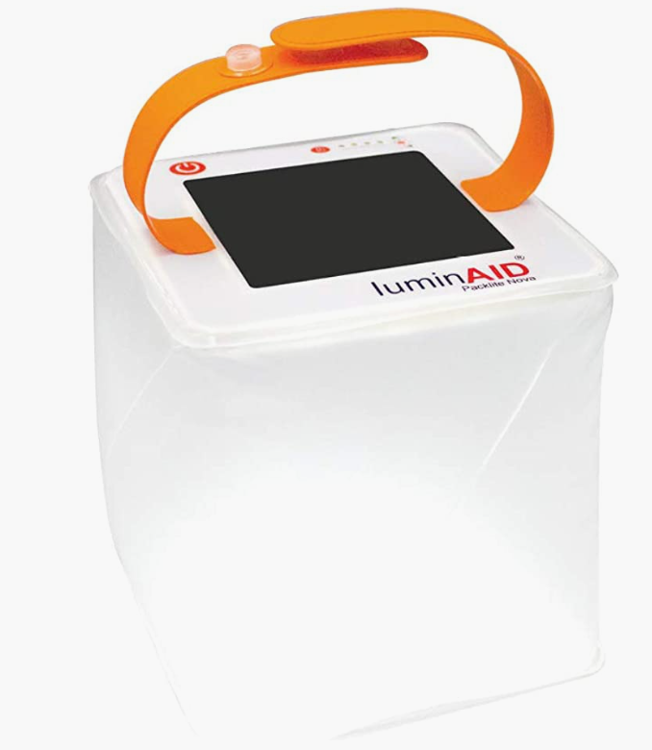

Filtered Water Straws
These can be used when water source is contaminated. These are small and portable and remove bacteria and parasites as well as microplastics found in the environment. You can store these in your 72-hour kits, your car, or in your home.

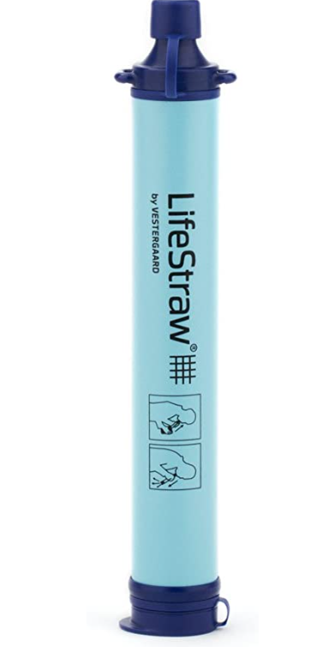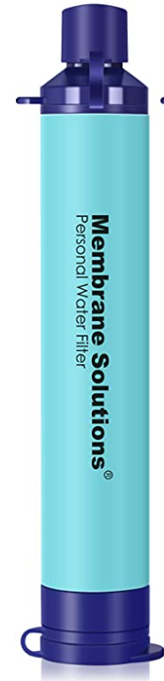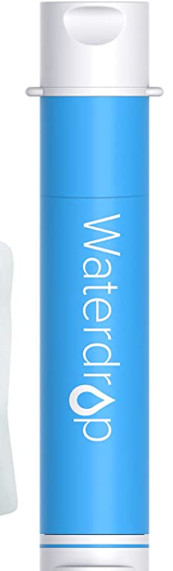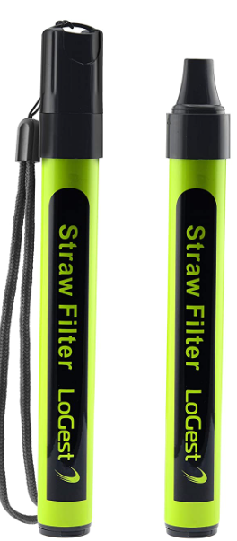

Water Filter Cases
These will help you keep them protected and everyone in your family could have one. They have different styles and colors available.
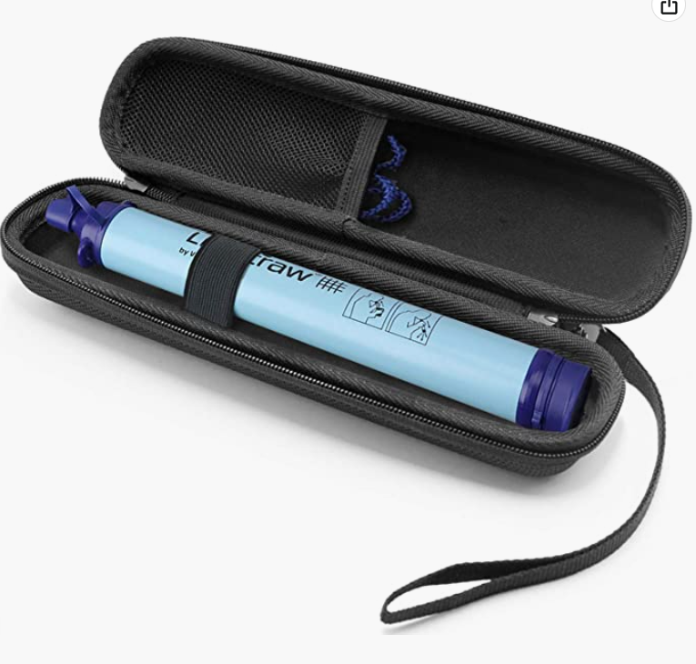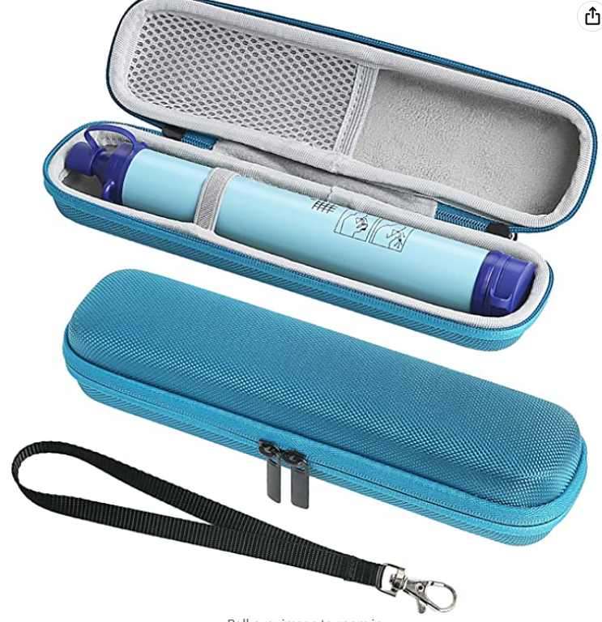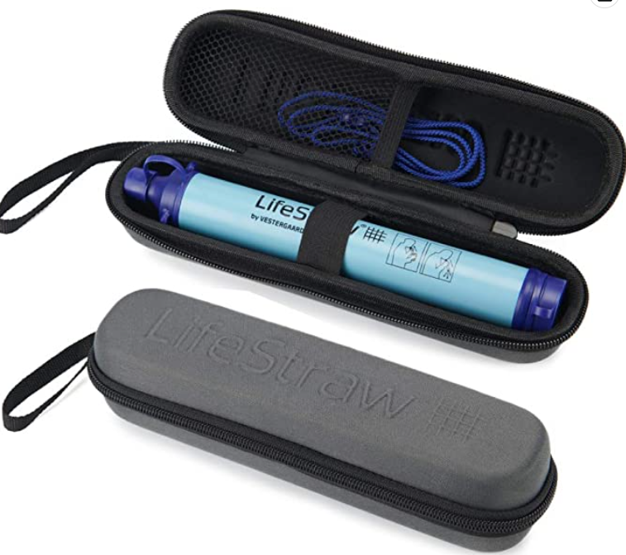

Butane or Propane Stove Burner
These are portable and can be used when electricity or other cooking options are not available.

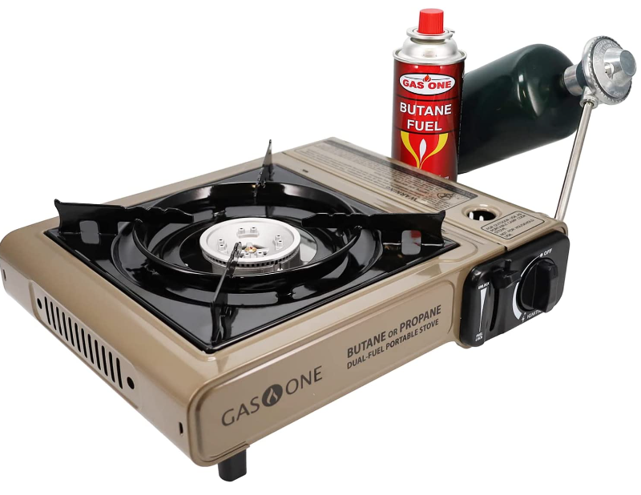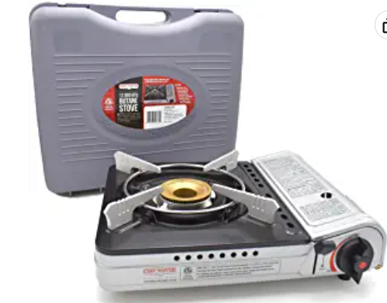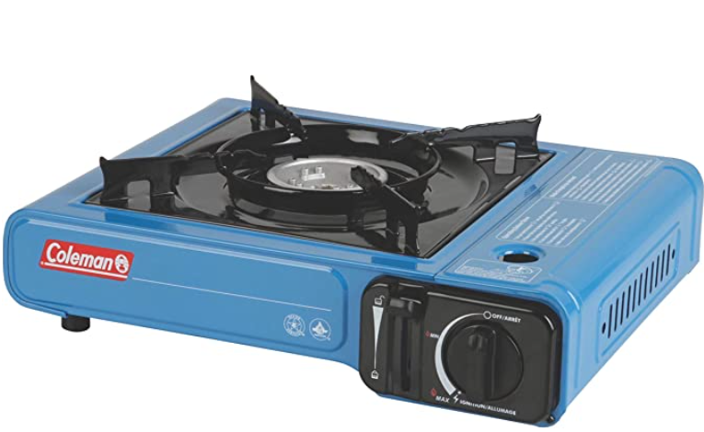

Car and Truck Camping Gear
These are good to have if you unexpectedly must camp on the road and stay in your car.
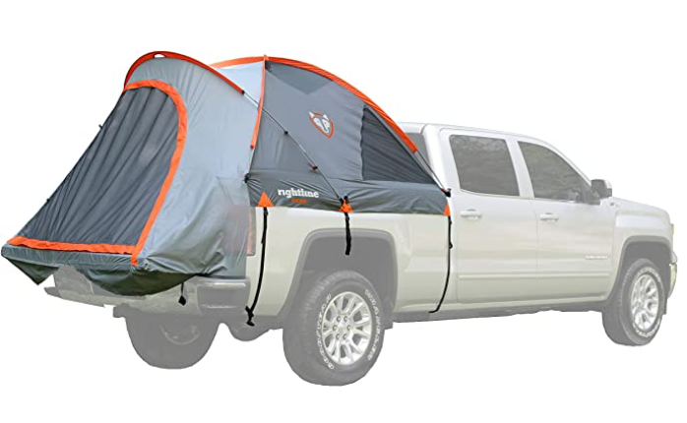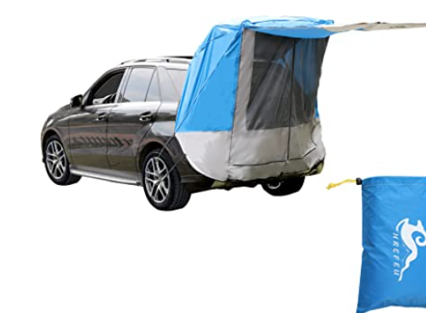

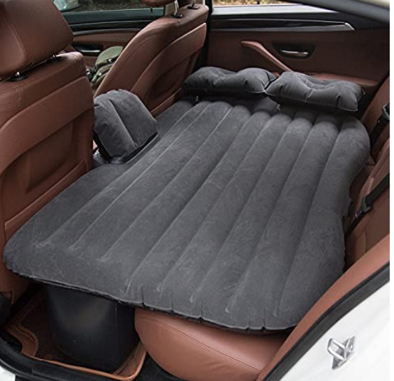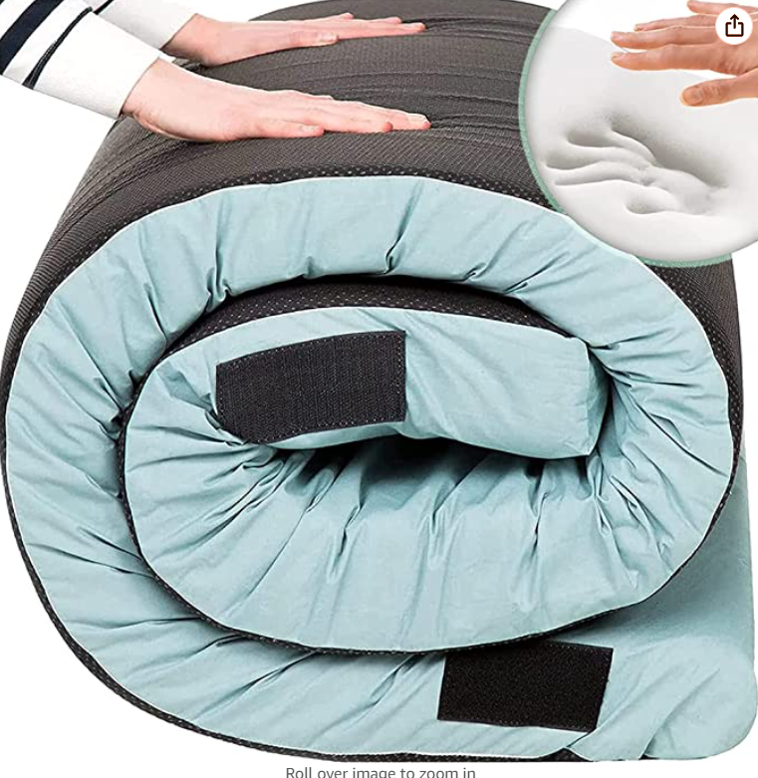

Portable Air Conditioner or Battery Powered Fans
Portable, rechargeable air cooler is great to have if you do not have electricity and it is hot.
