Sun Ovens

By Lori Toole

Pros:

* Free fuel source = Sun (Solar Powered)
* Cooks like a low to standard temp oven or a crockpot
* Cooks anything an oven does as well as some stovetop items (ie: rice, eggs, oatmeal)
* Easy to use
* Portable (lightweight)
* Doesn’t burn food (even if left to cook extra time) & no need to stir
* Can be used to sanitize water

Cons:

* Only works on sunny days (temperature is not so important – brightness is)
* Can take longer than traditional oven to cook (depends on brightness, wind, humidity, and season)
* Cook times can vary from one time to the next
* Needs adjusting every ½ hour to optimize temperature (but can be left to cook on its own if using like a crock pot) Must be moved to avoid shady areas if there are trees/buildings

Basic Tips:

Depending on the season and where you are located, the ideal time of day to use the oven will vary. Between 11am – 4pm is best in the cooler months (when daylight is shorter), but the window gets larger in the summer months (when the sun in more directly overhead) and the farther south you are.

Dark, lightweight pans and pots are ideal, but glass dishes may also be used. Non-shiny pots are useable but not as effective. Shiny dishes reflect the sun (and thus the power) away from the food and should not be used. 8x11 is the largest rectangle I can fit, but 2 can fit if rotated & stacked. 2 bread loaf pans can fit side by side. A 5 qt spaghetti pot will fit as will some roasters depending on shape and if they have handles. Pans can be purchased from a sun oven dealer, but they can also come from garage sales and second-hand stores – as long as they are dark and fit into the oven space. Mine is 14”x14”x7”tall. Lids should be used for everything except baked goods.

It is best to place dishes on the leveling rack so that as you focus and align the oven, food will not spill. If the pot is too large for the leveling tray, fold it under the pot so that air can still circulate for proper cooking. There are guides to help you optimize the oven’s location to the sun’s rays.

The ovens usually cook between 250-350* F, but can reach 400* (It can usually reach 300* in about 20 min.)

Adjust and align the sun oven as mentioned above to catch the full value of the sun and avoid any shade that might be encroaching. If you are unable to attend it that often, just pick the best spot for catching the sun’s rays for the longest period of time and leave it. Adjust your cook time to compensate. It will continue to work much as a slow cooker which is generally 200* on LOW or 300* on HIGH. You can verify meat is cooked sufficiently by using a meat thermometer (usually 165* for poultry and most ground meats; 145* for roasts, whole cuts, and pork).

It is an oven, so be sure to use oven mitts when lifting lids or removing pans from the oven. The outside of the oven and the reflective panels do not get hot, but the inside of the lid and inside the oven do.

There are recipes (and videos) online, but most regular oven recipes will work. Water may need to be reduced by 1/3 in rice, stews, and sauces, but not in baked goods.

# More Random Tips

Baking Bread:

* Preheat oven 1st
* Raise bread only to about ¾” below top of bread pan – when you open the pre-heated oven to put the bread in, temps will drop about 50* Then as it climbs, bread will rise more. Otherwise, it will rise too high and then fall.
* Spray a little water on top of bread (light mist) before putting in oven so bread will “brown” even if at a lower even if at a lower temp that day. Will brown even with temps as low as 225-250*.
* On a normal sunny day, 1 loaf takes about 45 minutes, 2 loaves take about 1 hour to 1 hour 10. On a partly cloudy day, probably takes more than 1 1/2 hours.

Anything that’s oven safe can be used in a sun oven.

If using a shiny pot, wrap in a dark towel to cover pot (nothing synthetic that might melt).

Nothing will catch fire in a sun oven, but things can melt.

Food will not burn in a sun oven.

Can cook an 18 lb turkey in a baking bag (just don’t cut slits).

Can use a dutch oven or cast iron pot if slow cooking all day. These will retain heat and keep cooking even if you lose your direct sunlight – just don’t open the door. Ideal range for slow cooking is 170-190 (<212* boiling point)

Always use a lid on pots to retain the moisture but leave things uncovered if “baking” them (desserts). So, to cook a roast and cobbler, put the roast in the bottom pot with a lid, then stack the cobbler on top with no lid.

If too much steam builds up on the glass, open the lid, wipe it quickly (careful, it’s hot!), and close it again. If it continues to build, place a small stick or chop stick end under the top corner to slightly vent the oven.

# Sun Oven Hacks

By Gemie Martin

Wikipedia says a “life hack” is “. . . any trick, shortcut, skill, or novelty method that increases productivity and efficiency.” In using my Sun Oven I have come up with a few “Sun Oven hacks” which have made cooking with my Sun Oven easier and more efficient. I wanted to share these hacks and a few of my favorite recipes that I cook in my Sun Oven with you.

**The Bean Bag Chair Hack.** The first hack is to replace the leg and stand with a bean bag chair. I found adjusting the leg of my sun oven to be difficult. I often had to get down on the ground to adjust the leg. It was time consuming and somewhat difficult. If what I was cooking had a lot of liquid in it, the jostling of adjusting the leg would cause liquid to spill out. I longed for an easier way to focus my Sun Oven to capture the most intense rays of the sun. I remember thinking, “If I could just swivel the oven around, it would be easier.” An idea came to me. I bought an inexpensive beanbag chair with a vinyl cover (so it can be wiped clean) and put it out in the middle of my back yard. I then set my oven in it. I was amazed at how much easier it was to focus my oven by swiveling it around in the beanbag chair. I have not used the leg since. If you do this, completely remove the leg so it does not poke a hole in the bean bag chair. I store my leg in the box my oven came in just in case we go camping and do not have enough space to take the bean bag along. In the early morning, you must set the oven back far enough into the bean bag chair such that it provides enough support so as not to let the oven tip over. (If this does not make sense to you now, it probably will after you try it.) As you gently swivel the oven around in the bean bag chair, use the trackers and focus your oven to capture the sun’s rays.

**The Silicone Baking Liner Hack.** The second Sun Oven hack, is to use a silicone baking liner or mat on the leveling rack of the Sun Oven. My older Global Sun Oven model (which I still own) has a leveling rack or shelf that had a lip on it. This seemed to limit how much sliding around the pots and pans could do. When I purchased my All American Sun Oven, I noticed that the leveling rack that came with it had no lip and my pots and pans with liquid in them were sliding around and spilling into the interior of the oven when I would adjust and focus it. I purchased a small silicone baking liner about 8 ¼" X 11½" (the size that fits a quarter-size sheet pan) and put that on the rack. It made a big difference. The liner seemed to grab the bottom of the pan, keeping it in place. It seems to have made no difference in how the food cooks and being silicone, it is safe to cook with even at high temperatures.

**The Pillow Cover Storage Hack**. I store my racks and other accessories (except the pans and bread pans) that came with my Sun Oven in a zippered pillow cover inside my Sun Oven. This keeps them from scratching the interior of the oven and at the same time saving space by using the oven itself as a storage container. I am sure a regular pillow case (and there are probably other things) would also work as well.

**One final tip from me: To protect your eyes, wear sun glasses when working with your Sun Oven.**

“Boiled” eggs: about 45 minutes – no water needed (but use cardboard egg crate)

“Boiled” Items:

Rice (usual recipe but cooked almost 1 hour)

Oatmeal (warmed water 1st about 15 min; then added oats for 5 min)

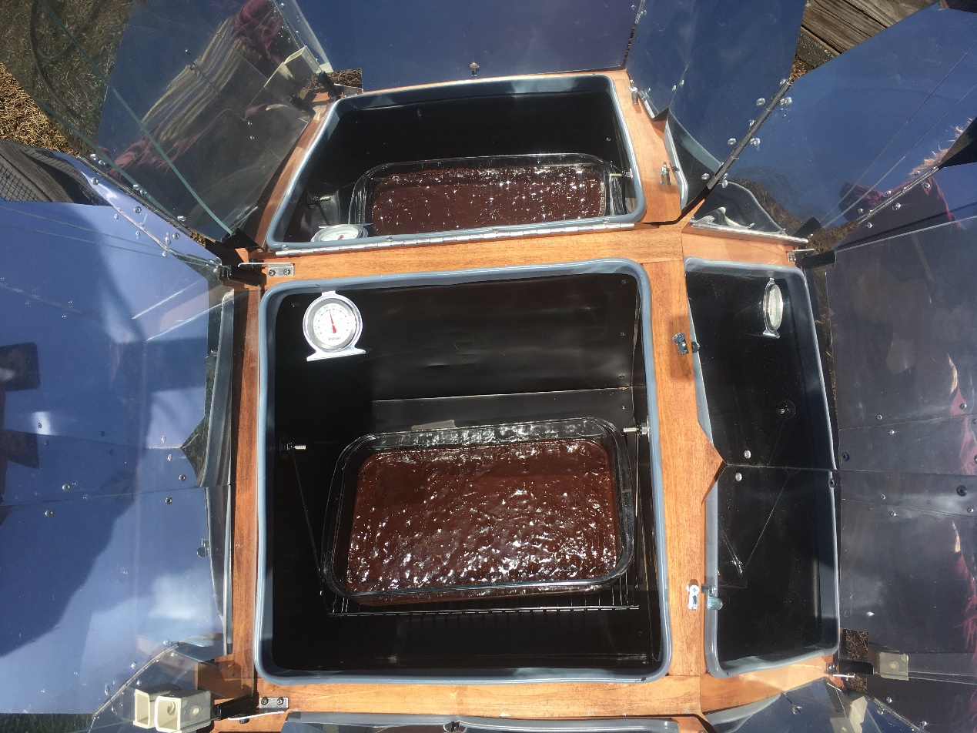

Brownies – Baked about an hour

Meatballs: Cooked 45 minutes

Roast: cooked 3 hours; shredded for BBQ

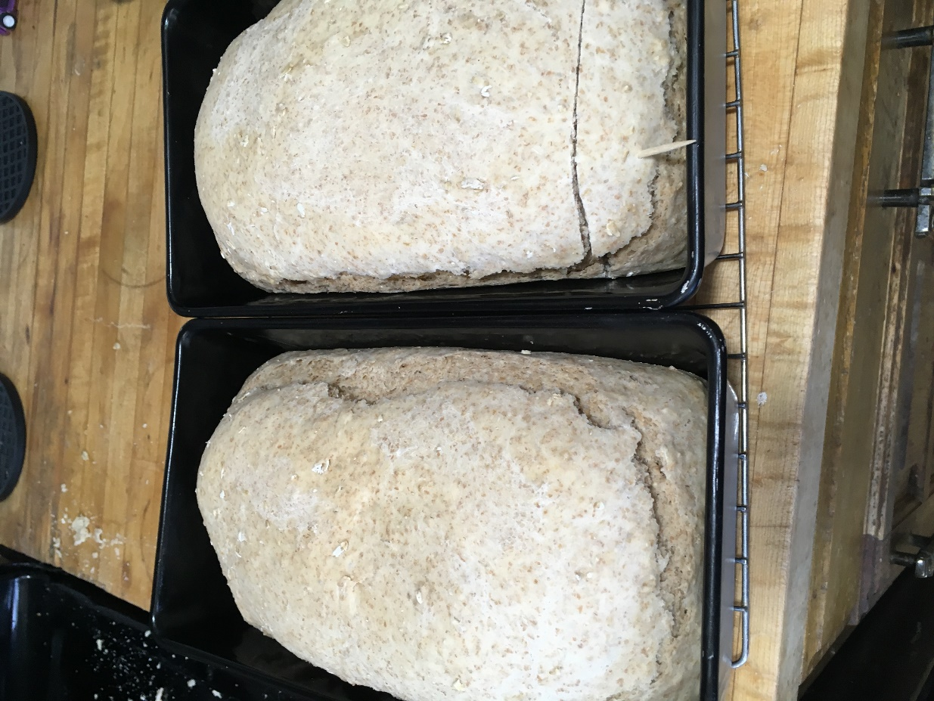

Bread: Baked 1 hr 15 min

Could have used 15 min more and didn’t brown well but tasted great!

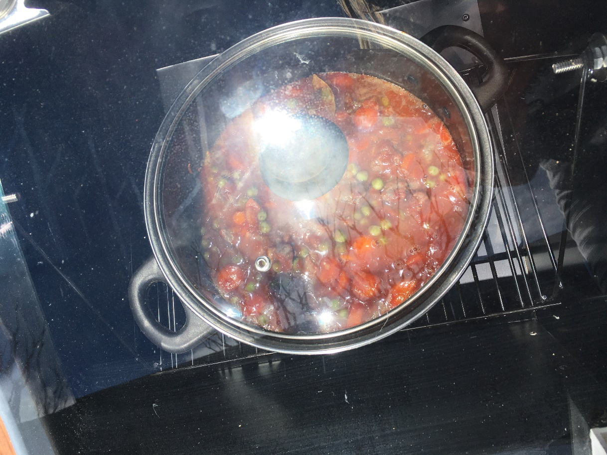

Beef Stew – Cooked 5 hours like a crockpot