Water-bath Canning (or also called Cold Pack Canning)

Fruits: Apricots, Peaches, Pears and Cherries
Peel (If you put the fruit in really hot water for 10 -15 min. the skin will remove very easy) You don't need to peal Apricots though), core or remove pit. Then slice in half or in smaller slices and place in the jars (fill the jar almost to the top with fruit stop just where it begins to form the neck of the jar). Add 3/4 to 1 cup of sugar (or even less if you choose) and then fill with warm water (only up to the where the jar begins to form the neck). Do not put past that or as it boils it will boil out and make it that the seal will not seal as well) use a knife and run down the side of the jar to make sure the water gets around all the fruit and the air bubbles are out. Wipe the rim of the jar off with a clean cloth to make sure there is no sugar on the rim. Place on the seal and the ring. Make sure the ring in screwed as tight as you can do it. Place the jar into your cold pack canner basket. Let them sit there while the water comes to a boil. Then once the water is boiling lower the bottles down into the water and process PINTS 25 minutes and QUARTS 30 minutes. Adjust 5 min. for every 1001-3000 feet. (when you lower them into the boiling water make sure the water is not covering the top of the jars). Once processing is completed raise the basket up and lift each jar out and place on the counter to cool. You will hear them pop which means they are sealed.
Berries: Strawberries, Raspberries

Strawberries and Raspberry can be left whole and don't have to be cut up. Place the berries in the jars (fill the jar almost to the top with fruit stop just where it begins to form the neck of the jar). Add 3/4 to 1 cup of sugar (or you can even use less) and then fill with warm water (only up to the where the jar begins to form the neck). Do not put past that or as it boils it will boil out and make it that the seal will not seal as well) use a knife and run down the side of the jar to make sure the water gets around all the fruit and the air bubbles are out. Wipe the rim of the jar off with a clean cloth to make sure there is no sugar on the rim. Place on the seal and the ring. Make sure the ring in screwed as tight as you can do it. Place the jar into your cold pack canner basket. Let them sit there while the water comes to a boil. Then once the water is boiling lower the bottles down into the water and process PINTS 15 minutes and QUARTS 20 minutes. Adjust 5 min. for every 1001-3000 feet. (when you lower them into the boiling water make sure the water is not covering the top of the jars). Once processing is completed raise the basket up and lift each jar out and place on the counter to cool. You will hear them pop which means they are sealed.

NECTAR Apricot, Peach and Pear: You do not even need to peel just slice and remove the pits or core. Throw into a large soup pan or your largest pan and add about a 1-2 cups of water depending on how large of a batch you do. Bring them to a boil stirring often to make sure it doesn’t stick to the bottom of the pan, simmer until the fruit is tender and soft. Once they are tender place about 4 cups at a time into your colander process using the wood tool push the fruit against the edge of the colander until all that is left are the peels. Lift out the colander and using a rubber spatula scrape down the sides then clean out the peels and keep going until all the fruit has been through your colander. Then place back on the stove and bring to a boil add water until it is the consistency you want for nectar. Add sugar until you get the taste you want. Once it has boiled and the sugar is dissolved you will ladle into your clean jars one at a time placing a seal and a lid on the jar. Make sure the ring is as tight as you can do it. You will need to hold the jar with a rag since the juice you are putting in will be very hot. Set aside and the lids will pop as they are sealed.
NOTE: (If you feel you can also water-bath these for 15 mins. if you want to make sure they seal well. I have never had to do this)

Applesauce:

This is done the same way as the nectar except once you have run through the colander and returned to your pan you will add cinnamon and sugar to taste. You can add Red-hot’s instead of cinnamon if you would like it will just make it a pink color you will still need to add some sugar too.
NOTE: (If you feel you can also water-bath these for 15 mins. if you want to make sure they seal well. I have never had to do this)

Tomatoes: From simplycanning.com Topic Canning Tomatoes (with no pictures though)

RAW PACK WHOLE OR HALVED METHOD.... NO WATER ADDED.
When you are canning tomatoes you have a choice as to how you want to process them. Canning directions for both the Water-Bath Method And The Pressure Canning method are included at the end of the page.

ACIDITY NEEDS TO BE ADDED FOR A WATER-BATH. THIS IS VERY IMPORTANT.
If you choose to use a water bath canner be sure to use lemon juice in each jar. 1T for each pint, 2 T for each Quart.

PREPARE YOUR INGREDIENTS AND CANNING SUPPLIES
Gather your canning supplies
Pressure Canner or Cold Pack Canner canning jars canning seals and rings
jar lifter (optional) canning funnel (optional) large pot or blancher
bowls large spoons sharp knife
towels and dish cloths
Ingredients
Tomatoes Salt Lemon Juice
Start by preparing your jars, and getting water in your canner heating.
1st Step Is Peeling The Tomatoes.
Most (not all) of the time when you are canning tomatoes you'll want to first remove the skins. Now this is an optional step. It is perfectly safe to just can them with the skins on. But the skins may be undesirable in some dishes. For the most part..... I skin them. (don't toss the skins! save them for the dehydrator, they make great tomato powder.) Depending on the size of the tomato, blanch 4 to 6 at a time. In these pictures I am working with Roma Tomatoes. I like them for canning because they are meatier than other tomatoes. They are smaller so I can fit more in the blancher. If you have a blancher or blanching basket, that makes it easier but you can also just use a slotted spoon and a big pot of boiling water.
1- Wash tomatoes and dip in boiling water for 30-60 seconds or until you see the skins split. Start counting as soon as your tomatoes hit the water. Don't wait for the water to come back to a boil to start your count time.
2-When you remove the tomatoes, drop immediately into sink or bowl of cold water to stop the cooking.
3-Slip off skins and quarter tomatoes. The skins should just slide off in your hands. Occasionally I'll use a knife on some stubborn spots.
Optional method to peel your tomatoes... freeze them first.

*****Very Important*****
If you are canning tomatoes in a water bath canner, add bottled lemon juice or citric acid to the jars. 1T per pint, 2T per quart. Add 1 teaspoon of salt per quart to the jars, if desired.

As you skin the tomatoes slice them in halves or quarters as you prefer. I will sometimes even leave my Roma tomatoes whole. Place them directly into your jars. Your jars should be warm when you are working with your tomatoes. I'll usually just have them in a sink or pan of hot water. You can also run a dishwasher rinse cycle with the jars and then leave them in the steamy dishwasher until you are ready to fill each one.

Press down on the tomatoes in the jar until spaces between them fill with juice. This will crush them slightly. Leave 1/2-inch head space. Repeat steps until all tomatoes are skinned and chopped. You may need to let your water come back to heat in between batches in the blancher.

Remove air bubbles with a small utensil. I find an orange peeler works great for this step. I also use a dinner knife.

Be sure and wipe the rims of your jars clean before placing your lids on. If there are bits of food it may interfere with the seal.
Place lids on the jars and process according to Water bath or Pressure Canning instructions.

Remember how your jars were hot when you filled them? They will most likely cool when you add the tomatoes. Thus you should have the water in your canner warm/hot but not boiling hot. You don't want a drastic change in temperature. Canning jars are pretty sturdy, so they will handle some temperature change... but I'd still not risk placing cool or even room temperature jars in boiling water.

So have the canner water hot but not boiling when you fill it with the jars.

Now keep in mind these are raw packed in their own juice. You should not add water to your jars. If you add water you change the acidity and there are different processing instructions.

Also keep in mind, these tomatoes will float. It is just a fact of this method of canning. Tomatoes will end up at the top of the jars after processing with more liquid at the bottom.

Processing directions; time and pressure requirements: Processing for a Pressure canner. Process both pints or quarts - process for 25 minutes. Be sure to adjust processing according to your altitude. See this altitude adjustments page.
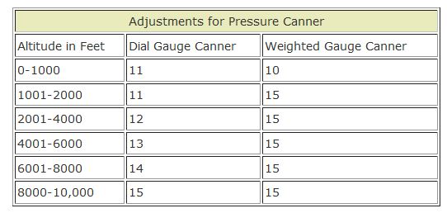
Processing for a water-bath canner. Processing for a Water bath Canner Be sure to add lemon juice to each jar.
Be sure to adjust processing according to your altitude. For more information see this altitude adjustments page.
Process both pints or quarts 85 minutes.
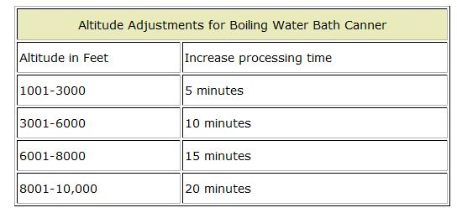

Meatless Spaghetti Sauce: Can be done with the Water-bath canner. BUT If you add meat you will have to use a pressure cooker to process. Go to http://www.simplycanning.com for the directions.

