Amateur Radio Classes

Plano Stake
Emergency Communications

1st class – Nov. 5th, 2nd class – Nov. 12th,
3rd class – Nov. 19th 4th class – Dec. 3rd,
5th class – Dec. 10th FCC exam – Dec. 17th

LDS Roundrock Chapel 2700 Roundrock Trail
Plano, Texas
Saturdays 9:00-Noon

Questions: Bob Bytheway 469-371-2629 or bob@K3DIO.com or
Dick Thiot 214-727-1363 or Dick@thiot.org

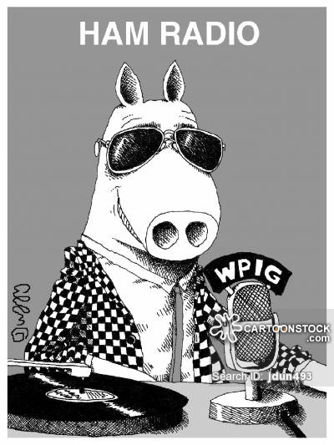
Amateur Radio Classes

Plano Stake
Emergency Communications

1st class – Nov. 5th, 2nd class – Nov. 12th,
3rd class – Nov. 19th 4th class – Dec. 3rd,
5th class – Dec. 10th FCC exam – Dec. 17th

LDS Roundrock Chapel 2700 Roundrock Trail
Plano, Texas
Saturdays 9:00-Noon

Questions: Bob Bytheway 469-371-2629 or bob@K3DIO.com or
Dick Thiot 214-727-1363 or Dick@thiot.org

