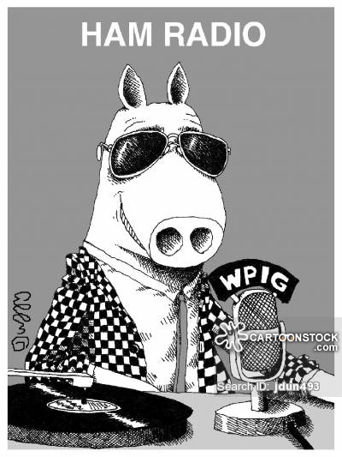
Amateur Radio Classes
Get your amateur radio license
Plano Stake Emergency Communications
1st class – November 5th, 2nd class – November 12th,
3rd class – November 19th 4th class – December 3rd, 5th class – December 10th FCC exam – December 17th
LDS Roundrock Chapel 2700 Roundrock Trail Plano, Texas
Saturdays 9:00-Noon
Questions: Bob Bytheway 469-371-2629 or bob@K3DIO.com or
Dick Thiot 214-727-1363 or Dick@thiot.org

