Rocket Stove and Other Homemade Stoves and Cooking Methods
To find this handout online go to: http://www.preparednessplano.org. Click on “Topics and Downloads” on the menu bar and find “2015 Fair Handouts.”
Rocket Stove Building Instructions (many different types of rocket stoves):
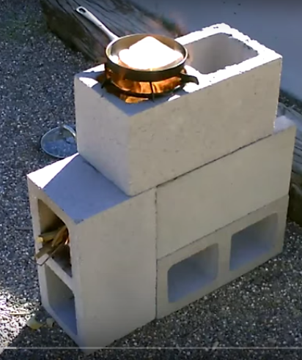
https://video.search.yahoo.com/search/video;_ylt=A0LEVxZgfOFV9rcAxv5XNyoA;_ylu=X3oDMTByMjB0aG5zBGNvbG8DYmYxBHBvcwMxBHZ0aWQDBHNlYwNzYw--?p=Rocket+Stoves&fr=yfp-t-901-s#id=16&vid=c475029a48dd591cd5bd7e76b552332f&action=view
4 Block Rocket Stove Instructions:
https://search.yahoo.com/search;_ylt=AnCR7c9i5yn5GgK.P0YX6dCbvZx4?fr=yfp-t-901-s&toggle=1&fp=1&cop=mss&ei=UTF-8&p=4%20block%20rocket%20stove
Stove in a Can Instructions:
http://www.peaceofpreparedness.com/Resource%20Library/Cookers/Stove%20in%20a%20Can%20instructions%202011.pdf
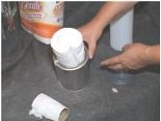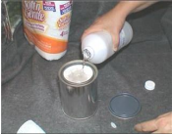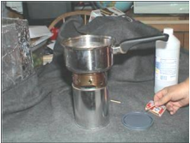
Instructions for many different Emergency Cooking Methods:
http://www.peaceofpreparedness.com/Resource%20Library/Cookers/No%20Power%20Cookers%20Directions%202011%20-%20ALL.pdf
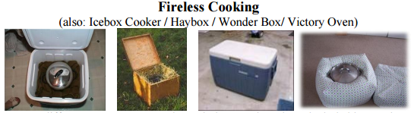
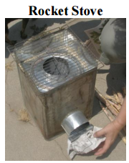
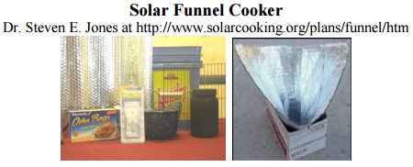
Also includes Applebox Oven and Dutch Oven Cooking information.
Wonderbox Instructions (Retained Heat Cooking):
http://www.peaceofpreparedness.com/Resource%20Library/Cookers/WonderBox%20Instructions%202011.pdf
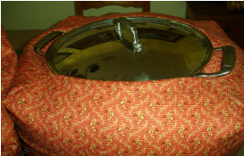
Wonderbox Pattern:
http://www.iwillprepare.com/cooking_files/Wonder_Box.htm
http://foodstoragemadeeasy.net/fsme/docs/wonderbox.pdf
The patterns above call for a 32" bottom but 33" works best. You can email Gemie Martin with questions or to trace her pattern: gemiemartin@gmail.com
Beads to fill the bag can be order from the web site below. It takes 1 1/2 bags
http://www.fairfieldworld.com/store/bead/poly-fil-micro-beads-1%C2%BC-pound-bag/
Cloudy Day Cube Stove. Purchase the cube stove and Fuel Disks (fire starters)
www.sunoven.com and http://www.quickstove.com/
