Emergency Prep. Products and Web Resources

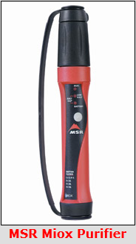http://www.miox.com/miox-solutions/MSR-MIOX-Purifier-Pen.aspx http://www.amazon.com/Water-Purifier-Portable-Coyote-Brown/dp $199.99
WINDMILL WINDPROOF LIGHTERS; 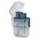
- Available at amazon and others, do a Google search About $ 45.00
MRE’s
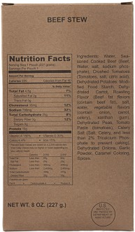http://beprepared.com/food/mres.html?SC=GOOGLE&OC=GOOG046037&gclid=CPqx39SXyLUCFQ6ynQodYEAAQw
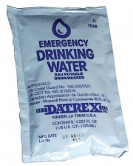Emergency drinking water, US coast guard water rations,
http://beprepared.com/water/prepackaged-water/datrex-water-pouches-case-of-64-4-ounce-pouches.html $19.95,

Just Water filter system http://shop.monolithic.com/pages/water-filters

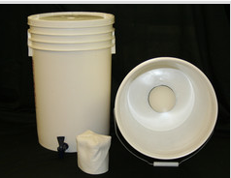Kit 57.50 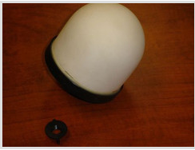Filter alone 27.50

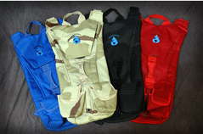Back Pack filter 43.95 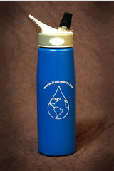 Bottle filter 19.95

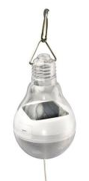Hampton Bay Solar Hanging White LED Bulb Light HD28620WH
DESCRIPTION: The solar hanging light bulb, light up tents and any other dark outdoor living space. Available on line at http://www.ecoupons.com/products/home-depot/243465111/MjAzMTgwMjQ5

Emergency Chemical lights, 6-8 hour light time. The Dollar Store, Parker and Custer, 2 pack $1.00

Items I sourced from amazon.com these are good quality items, the stove is “killer” works like a charm.

Trangia Spirit Burner with Screwcap
by Trangia
4.7 out of 5 stars See all reviews (144 customer reviews) | 5 answered questions

Price: | $14.27 & FREE Shipping on orders over $35. Details
In Stock.
Ships from and sold by Amazon.com. Gift-wrap available.

WoundSeal Powder, 4 ea
by Biolife, LLC.
4.5 out of 5 stars See all reviews (58 customer reviews)

Price: | $19.54 ($6.51 / Item)

Outdoor Camping Multi Functional Axe
by SumDirect
4.4 out of 5 stars See all reviews (42 customer reviews)

Sale: | $9.25
In stock.
Usually ships within 2 to 3 days.
Ships from and sold by E-mart (Ship from USA).
- functional axe for camping
- Ideal for Camping or Keeping in Vehicle for Emergency
- Axe for easy cutting

Full Tang Hunting Camping Knife, Flint Fire Starter, Sheath
by ASR Outdoor See the Amazon Page for this brand
3.9 out of 5 stars See all reviews (842 customer reviews) | 7 answered questions

List Price: | $13.20
Price: | $6.86 & FREE Shipping on orders over $35. Details
You Save: | $6.34 (48%)
In Stock.
Ships from and sold by Amazon.com. Gift-wrap available.

UltraFire Cree T6 LED 501B Flashlight 5 Modes Use 18650 Battery
by Meco
4.0 out of 5 stars See all reviews (294 customer reviews)
| 8 answered questions

List Price: | $49.95
Price: | $5.95
You Save: | $44.00 (88%)
In Stock.
Ships from and sold by ZHONG SHIYAN.

http://www.lanternnet.com/Merchant2/merchant.mvc?
These seem to be pretty good deals. They put out a fair amount of heat also some higher than others. But cost to operate is very low in the pennies per hour. This site has many to choose from
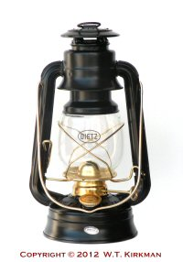
Dietz #20 Junior Cold Blast Lantern Item Code: DHL20 SALE: $10.95
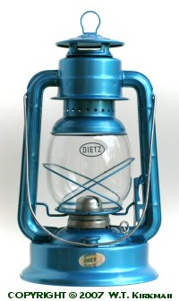
Dietz #90 D-Lite Cold Blast Lantern Item Code: DHL90 SALE: $15.95

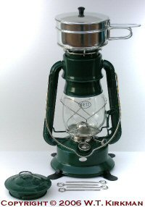
Dietz #2000 Millennium Cooker Lantern Item Code: DHL2000 SALE: $29.95

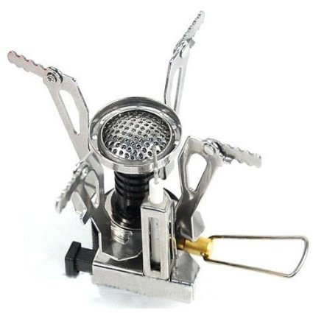

Qunqi Ultralight Outdoor Camping Stove Gas-powered Stove Cookout Butane Burner with box
by Housweety
1,270 customer reviews

List Price: | $29.99
Price: | $8.36 Free Shipping for Prime Members
You Save: | $21.63 (72%)

7W 300LM Mini CREE LED Flashlight Torch Adjustable Focus Zoom Light Lamp
by Ultrafire
3,453 customer reviews

List Price: | $9.99
Price: | $5.98 Free Shipping for Prime Members
You Save: | $4.01 (40%)

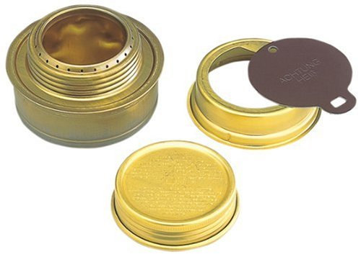

Trangia Spirit Burner with Screwcap
Price: | $14.70

DB POWER WF 501b Cree Xml T6 3 Mode Cree Led Flashlight 900 Lumens (Generic Packaging)
by WindFire®
Price: | $10.01 + $4.50 shipping

VISM by NcStar PVC First Responders Utility Bag
by NcStar

Survivor Outdoor Fixed Blade Knife with Fire Starter
by Survivor
Price: | $7.18

Survival Water Bags - Outdoors and Camping 1 Liter Stand Up Emergency Water Bag (Pack of 3)
by Nas-co

Additional Web resources for good info and supplies.

http://biology.clc.uc.edu/fankhauser/Cheese/CHEESE.HTML How to make cheese

http://www.redcross.org/services/

http://en.wikipedia.org/wiki/Gluten How to make gluten meat substitutes

http://www.augasonfarms.com

http://www.uscarb.com/a-c_kits.htm Natural gas conversion kits for most gen sets.

http://theepicenter.com/tow02236.html

http://www.ready.gov/build-kit/water

Feel free to contact me for additional information or for questions.

Scott Stone; 801-471-3138 ; scott.stone57@earthlink.net

