72 Hour Emergency Supplies

What items are in an emergency pack? Some of the categories are: water, food, first aid, tools, sanitation, clothing, and personal documents.

Why do I need an emergency pack? Emergencies vary from severe storms causing power outages, to tornados and earthquakes. Unfortunately, Texas is vulnerable to most types of catastrophes.

Where can I find a list of supplies to put in my pack? Go to www.ready.gov for a basic list from the Dept. of Homeland Security.

Who do I contact during or after an emergency? Call 2-1-1 from any landline phone or look online at www.211.org or texashelp.tamu.edu. For a complete list of agencies go to www.co.collin.tx.us/homeland_security/public_health/preparedness/PreparingForTheUnexpectedBooklet.pdf

Where do I put my emergency supplies? Put your supplies in a container such as a large trashcan, a camping backpack, a suitcase, or an ice chest. Keep this pack in an interior room or closet with no windows. You and your family will need to fit in this space for any emergency weather alerts.

How often do I rotate my emergency food? Eat the food in your pack every 6 months to avoid spoilage. You also will want to rotate clothes for growing children.

How to get started: Make sure to have 1 gallon of water per person per day for 3 days. Put a change of clothes in a plastic garbage bag to keep dry. First aid kits are available at most stores for $20-$25, but I recommend adding a few things like water purification tablets and diarrheic medication. Make copies of your birth certificates, marriage certificate, social security cards, driver’s license, and shot records and keep in a Ziploc bag. Create your own chart similar to this one for food.
 | Day 1 | Day 2 | Day 3
Breakfast | Cereal  Milk | Cereal  Milk | Cereal  Milk
Lunch | Peanut Butter  Crackers | Ramen Soup  Juice Drink | Peanut Butter  Crackers
Dinner | Refried Beans  Apple Sauce | Canned Soup  Canned Peaches | Madras Lentils  Fruit Snack
Snack | Protein Bar | Nuts | Pepperoni Stick

Other Resources:
ReadyShelby.org

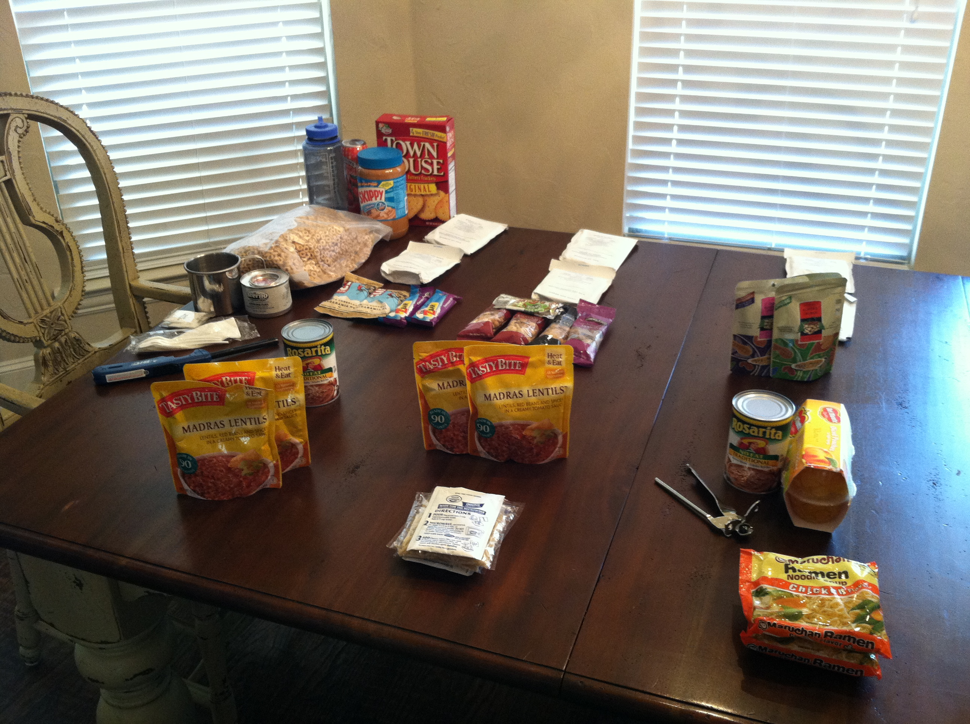
72 hours of food
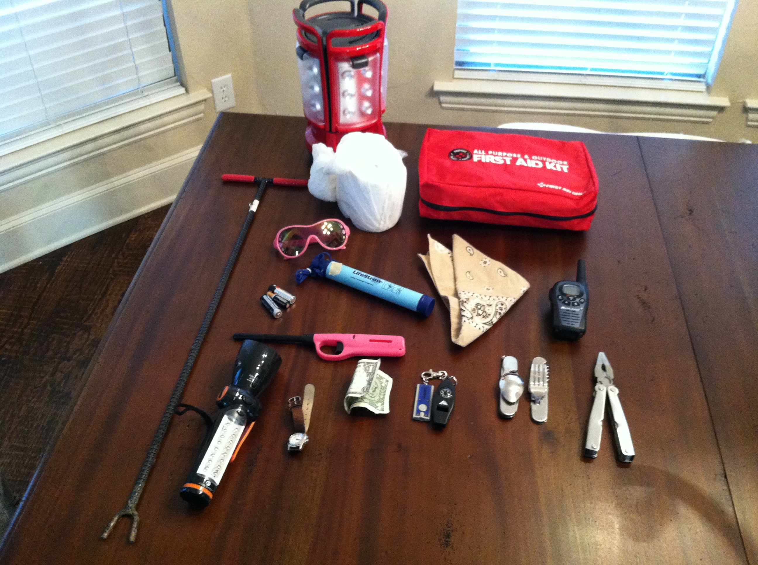
Emergency tools
Lantern, tool to turn off water-line, toilet paper, first aid kit, sunglasses, batteries, water filter, bandana, walkie-talkie, lighter, flashlight/radio, watch, cash, mini-light, compass/whistle, silverware, multi-tool with pliers

