Emergency Sanitation Practices for Individuals and Families

OUTDOOR Disposal of Human Waste

1-3 days (72-hour kit)

Follow ‘Leave Not Trace’ Principle 3: Dispose of Waste Properly (LNT.org)

Personal supplies per person ($3-5):

1 Small packet of tissue paper (or 3 unscented disposable wet wipes)

3 each 1-Quart or 1-Gallon zip lock plastic bags

1 Small bottle of Hand Sanitizer

‘Cathole’ - for rural dry area away from large groups and personal single use

Walk at least 100 steps (200’) away from streams, trails, walkways, and camps

Use a small 6” hand garden trowel ($5) or hand shovel ($15) to dig a hole 6-8” deep, 4-6” across

Place used tissue in cathole to bury or in a ziplock bag for later disposal

Refill soil in cathole and spread natural vegetation over covered hole

Hint: Unscented disposable wet wipes used for daily body cleansing can be kept in a 1-quart zip lock bag for reuse as a sanitary wipe before final disposal. Please do not bury wet wipes as they do not breakdown in the soil.

Tall kitchen plastic trash bag 12-15 gallon with drawstring (Box of 25 $5) placed in a 5 or 6-gallon bucket, or in a wastebasket. 1-3 uses each. The 5 or 6-gallon bucket can be used to store and transport sanitary supplies between uses. Optionally add powdered deodorant, disinfectant, decomposition chemicals or scented cat litter in bottom of bag. There are toilet seat covers if desired designed to fit buckets ($15).

Commercial human waste bag ($2-3 each, Box of 6 $12-15). 1 per person multiuse.

Self-contained chemical toilets for camping similar to those in RV’s are also available ($50-75).

INDOOR Disposal of Human Waste

1-3 days (72-hour kit) and Unlimited Period until sewer services are restored

Tall kitchen plastic trash bag 12-15 gallon with drawstring (Box of 25 $5) placed open in toilet bowl. First turn off water supply valve at wall. Flush toilet to drain tank and bowl. Put open end of trash bag under toilet seat inside the bowl and lower seat onto trash bag to hold in place. Dispose of used trash bags by tying tightly to prevent odor escape, then placing in a heavy duty trash bag 20-30 gallon with drawstring for longer term storage in garage or back porch where animals will not tear open and scatter until trash removal services are restored.

Commercial human waste bag ($2-3 each, Box of 6 $12-15). Multiuse. Plan 2-3 bags for each person for one week. Family of four should plan 2 boxes for each week of use.

Build a Portable Privacy Screen ($42)

Material List:
- (12) 3 to 3.5-foot sections of 1-inch PVC pipe $12 total

Hint: Buy (4) each 10-foot lengths for $3 each and cut into 3 sections of 3.0, 3.0, 3.5 feet (0.5’ leftover)

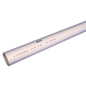
- (4) 1-inch PVC 90-degree Side Outlet Elbow (or ‘3-way coupling) $10 total

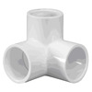
- (4) 1-inch PVC Coupling $4 total
- (2) Tarps with metal grommet holes (6 ft x 8 ft) $14 total
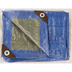
- (1) 50 foot rope $2 total
ASSEMBLY: Connect (2) two 3-foot sections of pipe using connectors to make (4) four vertical poles. Connect the (4) four 3.5-foot sections of pipe using the 3-way couplings to attach the tops of the four vertical poles. Thread the rope through the grommets along the 8 foot sides of the tarps to suspend around the frame.
Closed Toilet Seat holds Bag in place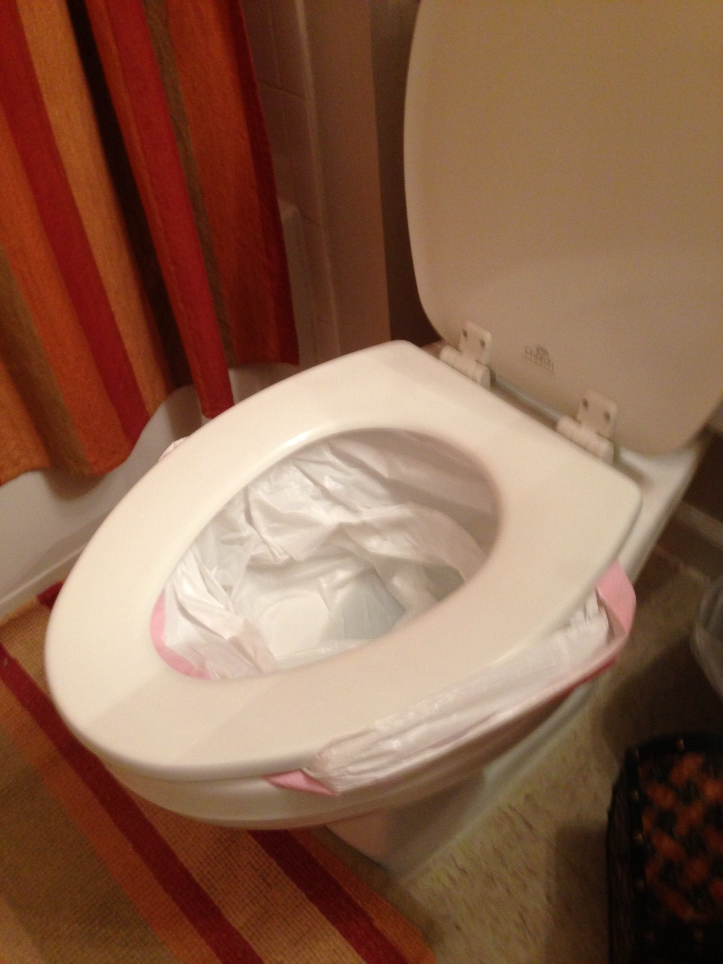
Tall Kitchen 13 Gallon Drawstring Trash Bag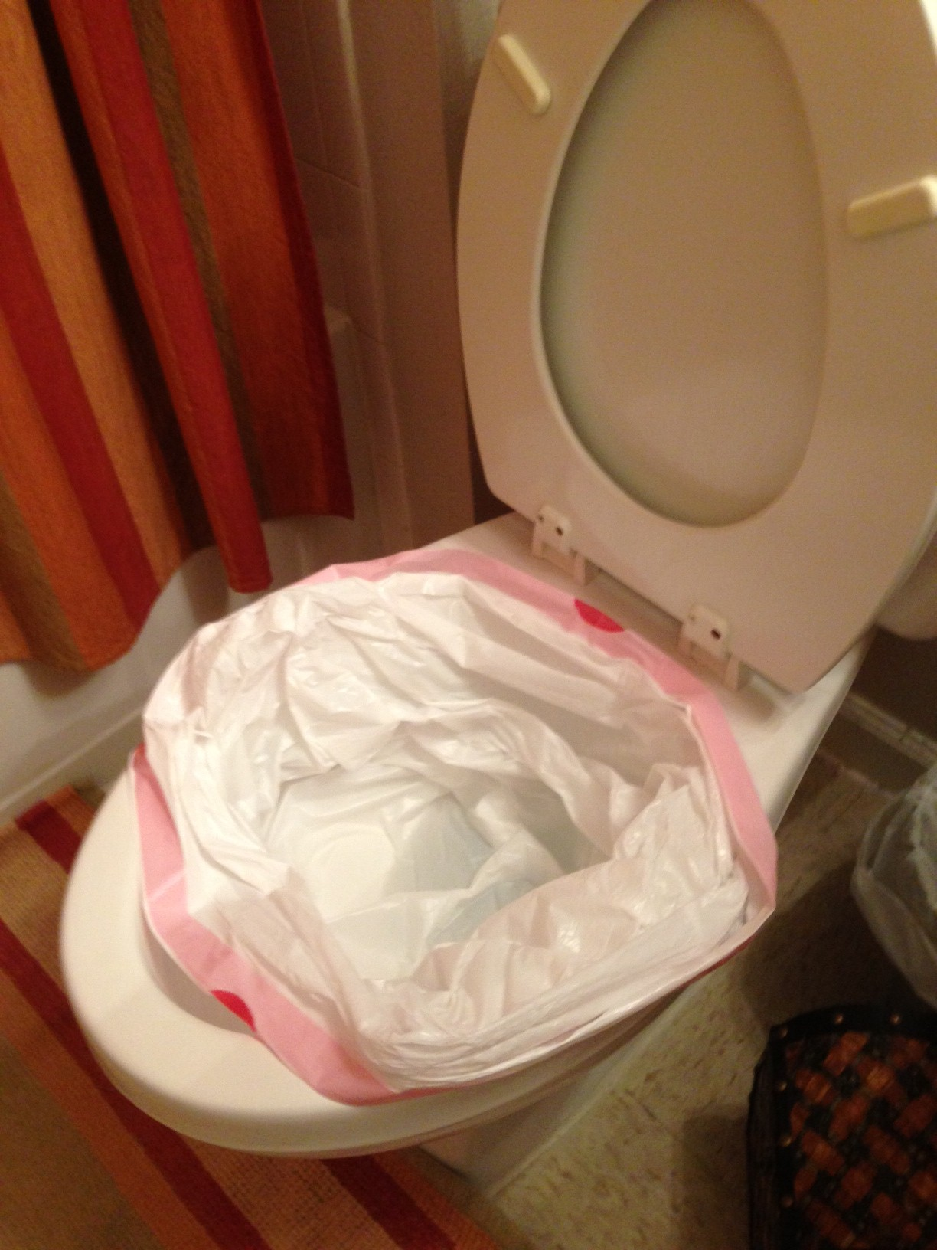
$79 Water Flush Toilet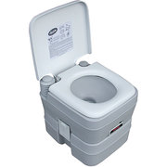
$45 Privacy Shelter 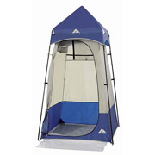
$50 Chemical Bag or Trash Bag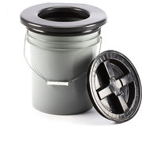
$35 Chemical (w/12 Bags)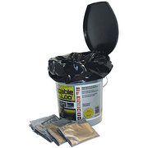
$12 (6 multiuse bags)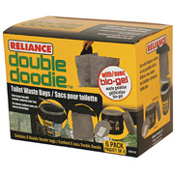
$25 Chemical Bag Toilet